

THANK YOU FOR BEING A PART OF OUR CHURCH DIRECTORY.
The church is a body with many members. In the New Testament letter of 1 Corinthians (Chapter 12), Paul speaks about the church as a body with many members. The metaphor of the body teaches that every person in the church matters and every person has an important ministry to keep the body strong and healthy. Church membership is a person’s commitment to the church to be an active, growing part of the community. At the same time, church membership is the church’s commitment to each member to be accountable for one another. So, we embrace church membership because it strengthens the body and strengthens each member of the body.

We recognize that staying connected to our members is a vital aspect of our ministry, and fostering connectivity within our church community is equally essential. Church is a place where people can meet Jesus, and engage in a life-giving community, and everyone is welcome. We believe in creating a space where people can have authentic encounters with Christ, discover their gifts, and use them for God's glory. Let’s Stay Connected!


Our church heritage spans more than a century. We have a rich heritage that stands out in the city of Covington. The public records of Tipton County show this ministry was established in 1910.

The Church of God in Christ, Covington, had its inception in 1910, during a “Brush Harbor” Revival Service with an Elder Turner as leader, and just a few followers. In 1919, Elder Turner and these followers purchased a small 8’ by 12’ house near the 409 Haynie Street site. The constituency consisted of a small group of females.

A few years later, a piece of land was purchased, and the small, framed building was moved. That building was torn down, and a larger building was erected and moved, with mules and logs, to the 409 Haynie Street site.

Elder H C Foster (deceased) was appointed pastor in 1926. Elder Foster organized the church July 17, 1926, with the following persons serving as deacons: Will Hill, Alvin Maben, Elder Nacy Parker, B. Chatman, and B. Hall. Mother Loura Burnett was serving as secretary.

Elder Foster envisioned the need for expansion, and, in 1935 the building was enlarged and later bricked. The membership grew to 122.
Elder Foster remained pastor until October 1956, when he resigned.

Bishop A B McEwen, who was presiding State Bishop, took over the reins as pastor in December 1956. Under his leadership, restrooms were added to the front of the building, and a two-story addition was added to the rear. Bishop McEwen was pastor until his death in February 1969.

Elder Charles Rodgers (now Bishop), ‘a man before his time’, was appointed pastor in May 1969 by the late Presiding Bishop, Bishop J O Patterson. Under Bishop Rodgers’ leadership, the church experienced great changes. These changes included: a Hammond organ, re-organizational church structure; purchase of church bus and van, as well as telephone services and a physical address and formal church name (Covington Church of God in Christ); Media Ministry (The Hour of Power); the McEwen Memorial Annex, the Moore-Burnett Fellowship Hall, an apartment complex, new classrooms, additional restrooms and offices; choir room and educational personnel rooms; audio/video space and extended choir area; purchase of land on the south side of the Haynie Street site, as well as the land directly across the street of the same site, and the land where the present church is erected.

Bishop Charles Rodgers served for 27.5 years. He resigned this ministry on December 31, 1996, and continued to serve full-time in the Memphis area.

December 31, 1996 (midnight) marked one of the high points in our church heritage and history…the changing of the guard. As Bishop Rodgers stepped down as pastor of the Covington Church of God in Christ, Elder Edward L Reed, his assistant, stepped up as pastor of said congregation. Pastor Reed was appointed pastor by our present Jurisdictional Bishop, Bishop Samuel Leon Lowe, prelate of Fifth Jurisdiction of Tennessee-Church of God in Christ.
Pastor Reed’s re-organization and additions were made to the leadership of the church, as well as a new edifice has been erected…the Great Expectations Ministries Church of God in Christ, 2053 Highway 51 South, Covington, Tennessee…this present site. From December 31, 1996, up to July 2012, Pastor Reed led this congregation with ministerial assistance only. On July 8, 2012, he appointed an assistant pastor, Minister DeJuan K Hall. Upon the demise of Pastor Edward Reed in July 2020, the assistant pastor, Elder Dejuan Hall was appointed pastor October 2020. God continues to bless our ministry as we champion under the leadership of Pastor DeJuan L Hall.

We are so grateful for the things the Lord has done, is doing and will do for this ministry. It is our desire to remain the beacon that will lead souls to a saving knowledge of Jesus Christ.


GEM believes that everybody is somebody; therefore, our mission is to embrace unity and impact the Kingdom of God while strengthening and encouraging each other, and the community in which we exist. We are here to empower, encourage, uplift, unify and learn through evangelism, training, and discipleship. We are committed to be the BEACON LIGHT that leads others to Christ, because our Kingdom assignment is to be the conduit for changing and transforming lives and communities globally. To see people saved, healed, set free, equipped, empowered, and serving. To make a lasting difference in the lives of individuals, in our homes, community, and in the world. Therefore, go make disciples of all nations, baptizing them in the name of the Father, and of the Son, and of the Holy Spirit, and teaching them to obey everything I have commanded you. And surely, I am with you, always, to the end of the age.” -Matthew 28:19-20 NIV


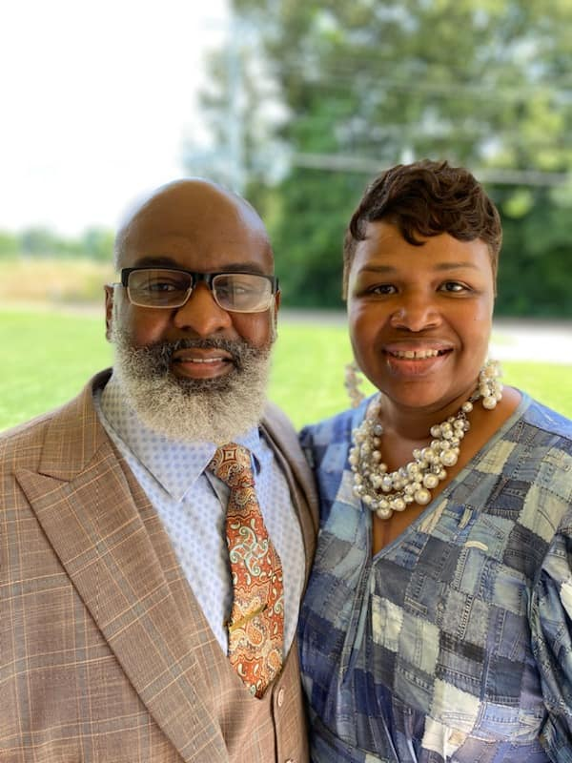
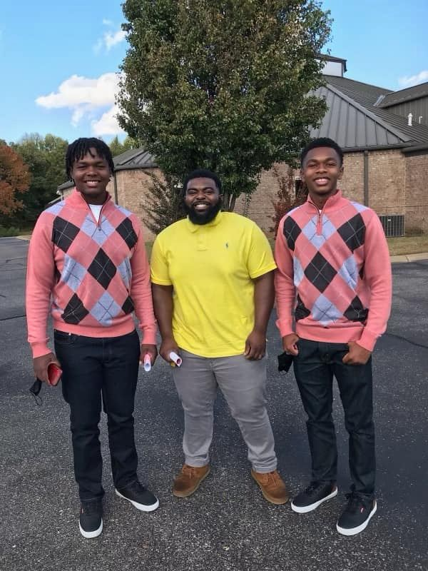
Pastor Dejuan &
Lady Tamara Hall
Jaylen, Keontae and
Cameron Hall

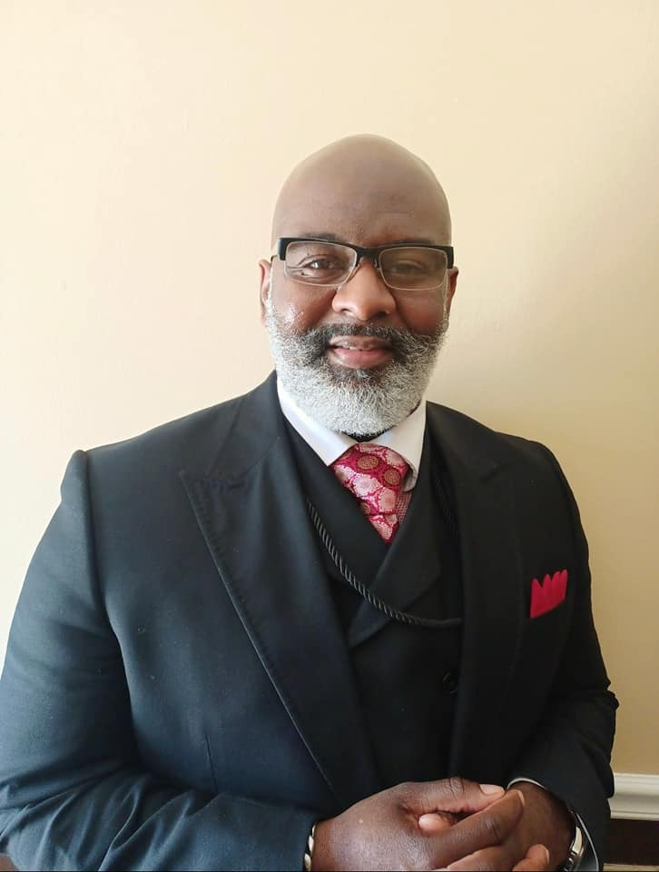
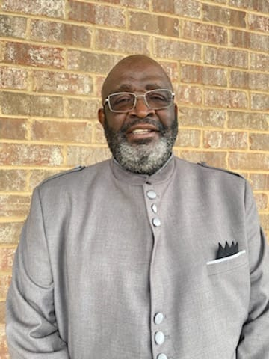
OUR
STAFF
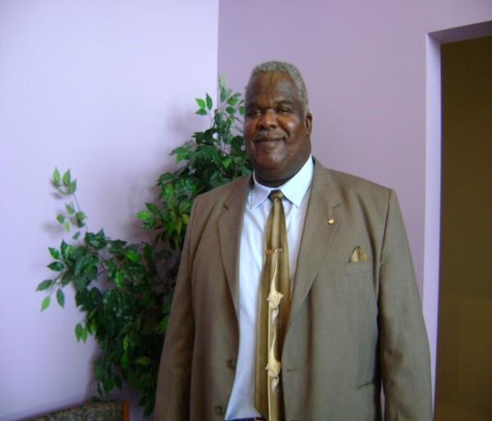
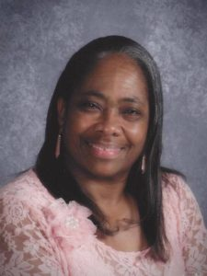
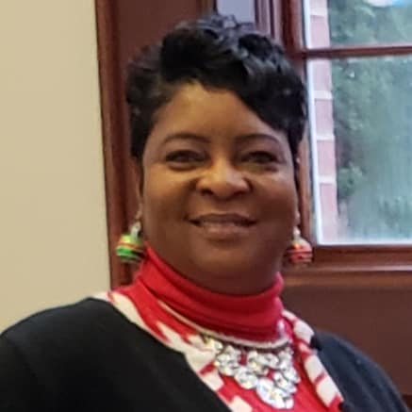
Elder Dejuan Hall
Pastor
(901) 481-0922
Deacon Robert Hall
Chairman of Executive Board
(901)
Elder Richard Bateman
Assistant Pastor
(901)
Executive Board Member

Sister Evelyn Hall
Financial Secretary
(901) 828-2877

Sister Rosalind Doggett
Assist Secretary
(901) 451-2844
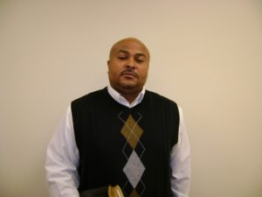
Min Cletis Foster
Minister of Music
(901)
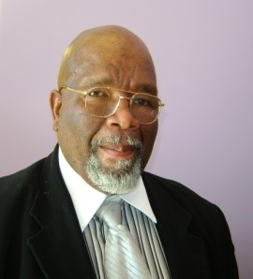
Minister Amos Topps Executive Board Member

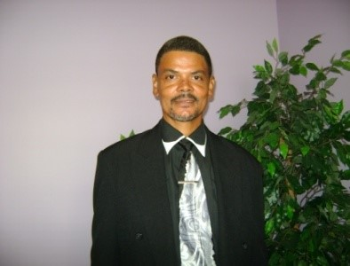
Minister Douglas Young
Executive Board Member
Deacon Joseph Burnett Executive Board Member
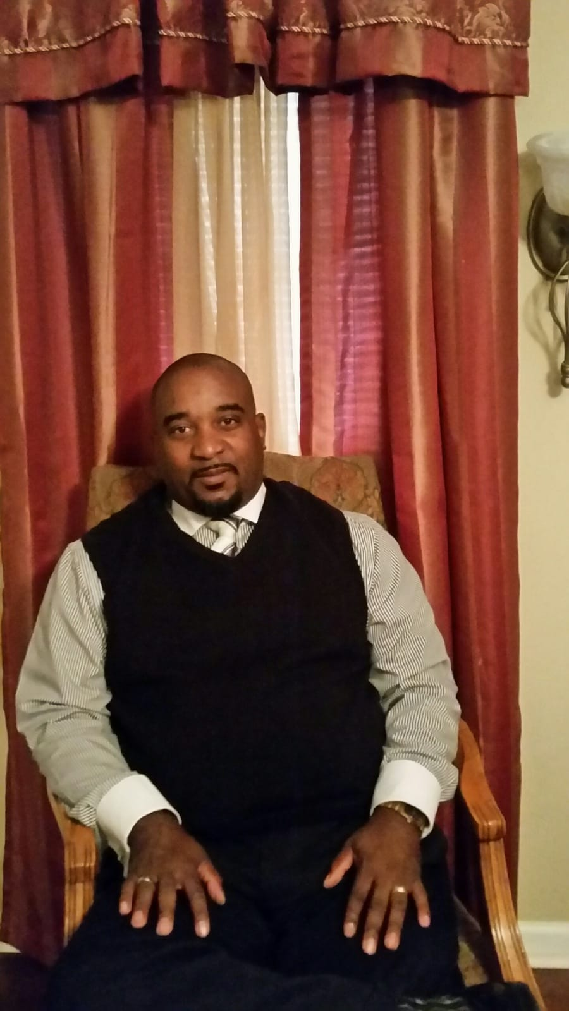
Deacon Ronald Hall
Executive Board Member

Deacon Jerry Hall
Executive Board Member

A
Adams Bonnie (Mother)
DOB: 2-10-48
Cell: 901-409-1673
Email:
Address: 278 Pickens Rd * Mason. TN 38049
Positions/Committees: Cell Coordinator
Hospitality Member
Member of Mothers Board

Adams Debra
DOB: 8-10-1957
Cell: 901-4 12-5612
Email:Debraadams845@Gmail.Com
Address: 3133 Hwy 14 S. Covington, TN 38019
Positions/Committees: Hospitality Member

Adams Derek
DOB:
CELL:
ADDRESS:
Positions/Committees: Hospitality

Adams DeRobert
DOB: June 2
Cell: (901) 451-7751
Email:
Address: 3133 Hwy 14 S. Covington, TN 38019
Positions/Committees: Choir Member
Assistant Teacher DOE
Assistant Coordinator Youth Activities

B
Bateman Richard (Elder)
DOB: 5/25/53 Wedding Anniversary: Oct 28,2023
Cell: 901-201-1071
Email: Bateman.Louis1@Yahoo.Com
Address: 190 Betty Boyd Lane Atoka, TN 38004
Positions/Committees: Asst Pastor
Asst Sunday School Teacher
Brotherhood Teacher

Bateman Sierra
DOB:
Cell:
Email:
Address: Ship 12 3515 Sailor Dr.* Great Lake, Illinois 60088
Positions/Committees

Bateman Susie
DOB: 12/20/60
Wedding Anniversary: 10/23/2023
Cell: (901) 489-6551
Email: rdaprincess60@yahoo.com
Address: 1247 Sadler School Rd East* Brighton, TN 38011
Positions/Committees: Pulpit Aide
Newsletter Staff
Good Shepherd Committee

Bernard Christopher
DOB: 9-11-2001
Cell: 901-483-5308
Email: CeoChris93@gmail.com
Address: 1101 Red Bud Cove* Covington, TN 38019
Positions/Committees:

Bernard Lisa Hill
DOB: 5-28-63
Cell: (901) 481-3886
Email: bernardlisa53@gmail.com
Address: 1101 Red Bud Cove* Covington, TN 38019
Positions/Committees: Usher

Blue Sharon
DOB: 7-19
Cell:
Email:bluesharon8@gmail.com
Address: 451 Lennanwood Ave. * Covington, TN 38019
Positions/Committees: Choir Member
Newsletter Staff

Bonds LaKesha
DOB: 3/24/80
Cell: 731-612-3994
Email: Kisha032480@Yahoo.Com
Address: 387 King Street * Ripley, TN 38063 Positions/Committees: Youth Department Assistant

Burnett Deirdre
DOB: 5-4-90
Cell: 901-687-7281
Email:
Address: 900 Peete Street * Covington, TN 38019
Positions/Committees:

Burnett Joseph (Deacon)
DOB: 12-16-57
Wedding Anniversary: 3-29-86
Cell: 901-451-4264
Email:
Address: 314 Woodmont Cove* Covington, TN 38019
Positions/Committees: Executive Board Member
Media Ministry (Sound Tech)
DOE Teacher

Burnett Sherri
DOB: 5-24-65
Wedding Anniversary: 3-29-86
Cell: 901-237-5541
Email: Sherriburnett707@yahoo.com
Address: 314 Woodmont Cove* Covington, TN 38019
Positions/Committees: Scholarship Fund Coordinator
Pulpit Aide Helper
Newsletter Staff

Burnett Tom
DOB: May 31,1944
Wedding Anniversary: June 24
Cell: 901-444-1050
Email: burnettirene959@gmail.com
Address: 900 Peete St *Covington, TN 38019
Positions/Committees: Usher Board

Burnett Irene
DOB: June 24
Wedding Anniversary: June 24
Cell:
Email: burnettirene959@gmail.com
Address: : 900 Peete St *Covington, TN 38019
Positions/Committees:

C
Catron Darlene P
DOB: June 22,1970
Wedding Anniversary:10-19-2019
Cell: 901-233-2456
Email: pasley_darlene@yahoo.com
Address: 4731 Charleston Mason Rd * Mason, TN 38049
Positions/Committees: Usher Board Member

Cochran Robin
DOB: March 24
Cell: 248-761-1577 Landline: 901-476-7651 Email: Cochran2448@Yahoo.Com
Address: 1647 Terry Lane , Covington, TN 38019
Positions/Committees: Usher Board Member

Craig Shalonda
DOB: 7/6/74
Cell: 901-921-4272
Email:
Address: 38 Tatlock Covington, TN 38019 Positions/Committees: DOE Teacher
Cohost Health & Healing

Craig Terence
DOB: 11/1/99
Cell: 901-921-4272
Email:
Address: 38 Tatlock Cr. Covington, TN 38019
Positions/Committees:

Craig Tyreece
DOB: 11/4/04
Cell: 901-921-4272
Email:
Address: 38 Tatlock Cr. Covington, TN 38019
Positions/Committees:

Craig Te’Shawn
DOB: 8/11/06
CELL: 901-921-4272
EMAIL:
ADDRESS: 38 Tatlock Cr. Covington, TN 38019
Positions/Committees:

Cunningham Amelia (Mother)
Dob: 8/2 Wedding Anniversary:
Cell:
Landline 901-475-0589
Email:
Address: 1242 Terry Lane Rd Covington, TN 38019
Positions/Committees: President Mother Board
Sunday School Teacher (Primary)

Currie Juanita
DOB: 3/16/66
Wedding Anniversary: Nov 23, 2021
Cell: 901-480-2454
Email: Juanitaburnett51@Gmail.Com
Address:
Positions/Committees: President of Usher Board

:
D
Davis Dorothy Hill
Birthday – May 6, 1956
Cell – (901) 317-0924
email: dorothy.aspire2mpower@gmail.com
700 Town Creek Rd. * Covington, TN 38019
Positions/Committees:
Missionary
Department of Education Coordinator
Scholarship Fund Assistant
Secretarial Assistant
Sunday School Asst Teacher
Newsletter Staff

Doggett Rosalind
DOB: 7/29/57 Wedding Anniversary: March 26
Cell: 901-451-2844
Email: Roz2009@Aol.Com
Address: 2286 Drummonds Rd. Munford, TN 38058 Positions/Committees: Assistant Church Secretary
Newsletter Staff

E
Edwards Angela
DOB:
Cell:
Email:
Address:
Positions/Committees:

Edwards Edith Diane
DOB: February 28
Wedding Anniversary: Sept 10th
Cell: 901-574-9997
Email:
Address: 201 Ervin Lane, Covington, TN 38019
Positions/Committees:

Edwards Kianna
DOB: 12/7/95
Wedding Anniversary: 7/29/2016
Cell: 901-216-
Email: EdwardsKianna-Ke@yahoo.com
Address: 8570 Blue Creek Circle * Millington, TN 38053
Positions/Committees:

Edwards Margaret (Mother)
DOB: 1-13
Cell: 901-786-8430
Email:
Address: 263 Groom Ave. * Covington, TN 38019
Positions/Committees: Mother’s Board
Sunday School Supt
YPWW President

Edwards Thomas
DOB: Feb 14, 1951
Wedding Anniversary: Sept 10th
Cell: 901 661-3205
Email:
Address: 201 Ervin Lane * Covington, TN 38019
Positions/Committees:

F
Fields Florence
DOB: 3/16/50
Cell: 901-596-6565
Email:
Address: 38 Tatlock Cr. Covington, TN 38019 Positions/Committees: Usher

Foster Cletis (Minister)
DOB: 12-18-73
Wedding Anniversary: 12/31/2004
Cell: 901-422-3445
Email: cletisfoster0@gmail.com
Address: 317 Sunset Ave. * Covington, TN 38019
Positions/Committees: Minister of Music
Ministerial Staff
Asst Teacher DOE

Foster Jeffika (Missy)
Dob: 2/15/78
Wedding Anniversary: 12/31/2004
Cell: 901-230-9272
Email: jeffikafoster@gmail.com
Address: 317 Sunset Ave. * Covington, TN 38019
Positions/Committees: Choir member

Foster Chayna
Dob: August 22
Cell: 08-22-06
Email:
Address: 317 Sunset Ave. * Covington, TN 38019
Positions/Committees: Choir member
Youth Dept member

Foster Cleahni
Dob: 10-21-05
Cell: 901-230-9272
Email:
Address: 317 Sunset Ave. * Covington, TN 38019
Positions/Committees: Choir member
Youth Dept member

H
Hall Cameron
DOB: 5-18-2006
CELL: 901-293-5771
Email: Camlakeehall@Gmail.Com
ADDRESS: 234 Holly Grove Rd * Covington, TN 38019
Positions/Committees: Choir member

Hall DeJuan (Pastor)
DOB: 07-13-1975
Wedding Anniversary: 9-13-2003
Cell: 901 481-0922
Email: Dejuanhall50@Gmail.Com
Address: 234 Holly Grove Rd * Covington, TN 38019

Hall Esther
DOB: 9-3-1956
Cell:
Email:
Address: 423 Hall St. * Covington, TN 38019 Positions/Committees:

Hall Evelyn
DOB: 12-9-65
Wedding Anniversary: 7-22-89
Cell: 901 828-2877
Email: hallevelyn@att.net
Address: 209 Groom Ave* Covington, TN 38019
Positions/Committees: Financial Secretary
Choir member

Hall Gwendolyn
DOB: August 6,1962
Cell: 901-483-8771
Email:
Address: 413 Peete St * Covington, TN 38019
PO Box 566
Positions/Committees: Missionary
Pulpit Aide
Good Shepherd Committee Chairperson

Hall Jaylen
DOB: 5-27-2005
Cell: 901-661-1705 Email:Dejuanjay10@Icloud.Com
Address: 234 Holly Grove Rd * Covington, TN 38019
Positions/Committees: Choir member

Hall Jerry R
DOB:
Wedding Anniversary:
Cell:
Email:
Address:
Positions/Committees: Media Ministry

Hall Jerry W (Deacon)
DOB: January 1
Cell: 901-586- 4190
Email:
ADDRESS:
Positions/Committees: Executive Board Member

Hall Keontae
DOB: 8-11-2000
Cell: 901-208-2346
Email: Keontaehsll38@gmail.com
Address: 516 Stone Ave 8 Covington. TN 38019
Positions/Committees:

Hall Robert (Deacon)
DOB: June 7,1945
Cell: 901-389-0265
Email:
Address: 617 Walton Loop * Covington, TN 38019
Positions/Committees: Chairman/Executive Board Member
Sunday School Assistant Superintendent
Training Union Vice President

Hall Ronald (Deacon)
DOB: October 18,1964
Wedding Anniversary: 7-22-89
Cell: 901-828-2289
Email: ronaldhall209@gmail.com
Address: 209 Groom Ave* Covington, TN 38019
Positions/Committees: Executive Board Member
DOE Teacher/assistant

Hall Stephen (Deacon)
DOB: 4/24/69
Cell: 901-304-7298
Email: Sh204087@Gmail.Com
Address: 258 Tatlock Circle Covington, TN 38019 Positions/Committees: Usher
Deacon Board

Hall Tamara (Lady)
DOB: 09-13-1975
Wedding Anniversary: 9-13-2003
Cell: 901-481-6132 Email: Halltamara13@Gmail.Com
ADDRESS: 234 Holly Grove Rd * Covington, TN 38019
Positions/Committees: DOE Secretary
Cohost Health & Healing Ministry

Harris Eula R (Mother)
DOB: 5/5/50
Cell: 901-317-8457
Email: eharris5550@gmail.com
Address: 259 Groom Ave. Covington. TN 38019
Positions/Committees: Church Mother
Missionary
DOE Teacher
Custodian

Hicks Henrietta
DOB: 2/18/32
Cell: 901-616-7711
Email:
Address: 4064 Beaver Creek Dr. Mason. TN 38049
Positions/Committees: Church Mother

Hicks Melvin (Deacon)
DOB: 4/16/59
Cell: 1-731-612-4819
Email:
Address: 568 Caroline St. (PO Box 454)
Henning. TN 38041
Positions/Committees: Deacon Board

J
Jenkins Dalton (Deacon)
DOB: 11-22
Wedding Anniversary: 8-3
Cell:313-585-3479 Home:901-835-0404
Email: drjenkins1719@att.net
Address: 3159 Quito Drummonds Rd *
Millington, TN 38053
Positions/Committees: Maintenance
Deacon

Jenkins Delphine
DOB: 10-18
Wedding Anniversary: 8-3
Cell: 517-896-9998 home:901-835-0404
Email: ne5iz5656@yahoo.com
Address:3159 Quito Drummonds Rd *
Millington, TN 38053
Positions/Committees: First Lady’s Armor Bearer
L
Love Barbara
DOB: 11-3-65
Cell: 901-569-1344
Email:
Address: 1888 Cotton Wood * Covington, TN 38019
Positions/Committees: Usher Board Member

M
Maxwell Cleola
DOB: November 26
Wedding Anniversary: 10/8/60
Cell: Landline: 901-476-7651
Email:
Address: 1647 Terry Lane , Covington, TN 38019
Positions/Committees: Usher Board Member

Maxwell Curtis
DOB: August 28
Wedding Anniversary: 10/8/60
Cell: Landline: 901-476-7651
Email:
Address: 1647 Terry Lane , Covington, TN 38019
Positions/Committees: Usher Board Member

R
Reed Gloria (Mother)
DOB: May 1, 1946
Cell: 901 734-2110 Landline: (901) 476-3547
Email:
Address: 400 N Main St, Covington, TN 38019
Positions/Committees: Mother’s Board Member
DOE Director

S
Seals Andray M
DOB: 10-04-70
Wedding Anniversary: 8-28-04
Cell: 901-355-9811 Home:901-937-5199
Email: tedseals@bellsouth.net
Address: 4616 Tulip Bend Dr. * Memphis, TN 38135
Positions/Committees:

Seals Cherlyn
DOB:7-29-70
Wedding Anniversary: 8-28-04
Cell: (901) 3781554
Email: cherlynseals@bellsouth.net
Address: 4616 Tulip Bend Dr. * Memphis, TN 38135
Positions/Committees: Welcome Center Greeter
Hospitality

Smith Mable (Mother)
DOB:
Cell:
Email:
Address:
Positions/Committees: Church Mother
DOE Teacher

Stokes Kylus
DOB: 09/13/07
Cell: 901-247-4817
Email:
Address: 387 King Street * Ripley, TN 38063 Positions/Committees: Youth Department member

Stokes LaKavius
DOB: 01/11.06
Cell: 901-592-9711
Email:
Address: 387 King Street * Ripley, TN 38063 Positions/Committees: Youth Department Member
T
Terry Trevon
DOB:
Cell:
Email:
Address:
Positions/Committees:

Toomes Whitley Joyce
DOB: 8/27/59
Wedding Anniversary: 9/29
Cell: 731-780-5757 Email:Joycetoomes.5912icloud.Com
Address: 818 Wadsworth Rd. Henning, TN 38041
Positions/Committees: Usher Board Member

Topps Amos (Minister)
DOB: June 28, 1953
Wedding Anniversary: 5-24-74
Cell: Home:901-476-5462
Email: toppsbobbie@gmail.com
Address: 522 Rosedale Ave *Covington, TN 38019
Positions/Committees: Deacon
Executive Board Member
Ministerial Staff
Topps Bobbie
DOB: 4-12-51
Wedding Anniversary: 5-24-74
Cell: Home:901-476-5462
Email: toppsbobbie@gmail.com
Address: 522 Rosedale Ave *Covington, TN 38019
Positions/Committees: Missionary
DOE Teacher
Welcome Center Member
Topps Christopher
DOB: 7/5/2008
Cell: 901-493-2885
Email:
Address: 1241 Old Brighton Rd. Covington, TN 38019
Positions/Committees: Choir Member
Youth Department member

Tyus Brianna
DOB: 03-03-1999
Cell: 901-849-9243
Email: Briannantyus@Gmail.Com
Address: 700 Town Creek Rd * Covington, TN 38019
Positions/Committees:

Tyus Joshua
DOB: 9-14-2001
Cell: 901-451-7746
Email: tyusjoshua@yahoo.com
Address: 201Ervin Lane* Covington, TN 38019
Position/Committees

Y
Young Douglas (Minister)
DOB: 7/18/59
Wedding Anniversary: 7/3/93
Cell: 901-569-9716
Email:
Address: 299 Ervin Lane Covington, TN 38019
Positions/Committees: Ministerial Staff
Executive Board Member
Deacon
DOE Teacher

Young Jacqueline
DOB: July 31,1960
Wedding Anniversary: 7/3/93
Cell: 901 395-3103
Email:
Address: 299 Ervin Lane Covington, TN 38019 Positions/Committees:



CELL MINISTRY
The Cell (small group) Ministry concept had its origin in the Word of God when God used Adam and Eve to multiply and nurture mankind. God also used Noah and his family (Gen. 7:11) to demonstrate His love to mankind by allowing them to replenish the earth after the flood. Jesus brought together a small group of twelve (12) with whom He spent much time nurturing and preparing for leadership in physical absence. Those twelve (12) led thousands to a salvation experience. The church grew from 120 to 3,000 after one sermon was preached by Apostle Peter (Acts 1:15). However, after this tremendous growth, there was a great need for nurturing, worship, fellowship, and witnessing. A small group of apostles taught and shepherded them. A small group of seven (7) deacons were appointed to look after their temporal needs. Members of the body (local church) can receive better and more efficient care through the cell (small group) ministry even in an extremely large church.

CELL NUMBER 1
CELL NAME: Ministers & Deacons
Members:
Elder Richard Bateman - Leader
Pastor DeJuan Hall Deacon Jerry Hall
Min. Douglas Young Deacon Ronald Hall
Deacon Robert Hall Deacon Jerry Hall
Minister Amos Topps

CELL NUMBER 2
CELL NAME: Mother’s Board
Members:
Mother Amelia Cunningham - Leader
Mother Eula Harris Mother Margaret Edwards
Mother Gloria Reed Mother Mabel Smith
Mother Henrietta Hicks

CELL NUMBER 3
CELL NAME: Good Shepherd & Pulpit Aide
Members:
Missionary Gwendolyn Hall - Leader
Sister Susie Bateman Sis Sherri Burnett
Lady Tamara Hall Sis. Delphine Jenkins
Missionary Dorothy Hill-Davis

CELL NUMBER 4
CELL NAME: Hospitality & Welcome Center
Members:
Mother Bonnie Adams - Leader
Sister Edith D Edwards Sister Debra Adams
Bro. Derek Adams Sister Irene Burnett
Sister Esther Hall Sis Rosalind Doggett
Missionary Bobbie Topps Sis Cherlyn Seals

CELL NUMBER 5
CELL NAME: Ushers
Members:
Sister Juanita Currie - Leader
Sister Barbara Love Sister Darlene Catron
Sister Robin Cochran Sister Cleola Maxwell
Sis Florence Fields Sister Joyce Toomes
Brother Stephen Hall Brother Tom Burnett
Brother Curtis Maxwell

CELL NUMBER 6
CELL NAME: Choir
Members:
Minister Cletis Foster - Leader
Brother DeRobert Adams Sister Evelyn Hall
Sister Sharon Blue Sister Missy Foster
Sister Jacqueline Young

CELL NUMBER 7
CELL NAME: Youth Department
Members:
-Leader
Sis. Kesha Bonds Cameron Hall
Christopher Topps Chayna Foster
Cleahni Foster Te’Shawn Craig
Tyreece Craig LaKavius Stokes
Kylus Stokes
Nehemiah Taylor

CELL NUMBER 8
CELL NAME: Children Department
Members:
-Leader
Amiyah Grace Tyus Madison Young
Aubrey Young Aniya Whitley
Amari Whitley Draya Burnett

Drayden Burnett Kendall Burnett
Kinsley Edwards Carter Edwards
Noah Taylor

CELL NUMBER 9
CELL NAME: Young Adults
Members:
Sister Shalonda Craig - Leader
Brother Terence Craig Brother Jaylen Hall
Brother Hall Keontae Brother Terry Trevon
Sister Brianna Tyus Brother Joshua Tyus
Sister Sierra Bateman Brother Christopher Bernard

CELL NUMBER 10
CELL NAME:
Members:
-Leader
Brother Andray M Seals Sister Angela Edwards
Brother Thomas Edwards Brother Dalton Jenkins
Brother Melvin Hicks Sister Kianna Edwards
Sister Deirdre Burnett Sister Patricia Taylor
Sister LaCree Taylor Sister Khylee Dowell


Amiyah Grace Tyus Madison Young Aubrey Young Aniya Whitley Amari Whitley Draya Burnett Drayden Burnett Kendall Burnett Kinsley Edwards Carter Edwards



Sister Patricia Taylor
29 Birchwood LN #2 * Jackson, TN 38305
PH:
Sister LaCree Taylor
29 Birchwood LN #2 * Jackson, TN 38305
PH:

Nehemiah Taylor
Noah Taylor


PERFECT IMAGE BARBER & BEAUTY SHOP
Pastor DeJuan Hall, owner
901-476-7788
115 Court Sq. W * Covington, TN 38019

THE JEWELZ VAULT
Jewelry Accessories
Dorothy Hill-Davis, owner
700 Town Creek Rd * Covington, TN 38019

ELEGANTLY BEAUTIFUL U
Juanita Burnett, Owner
Hair Stylist
901-296-5585
Business Hours: Thursday-Saturday 9am-2pm

BLESSED BEAUTE’ BAR
Brianna Tyus, Owner
Hair Stylist
901-849-9243

