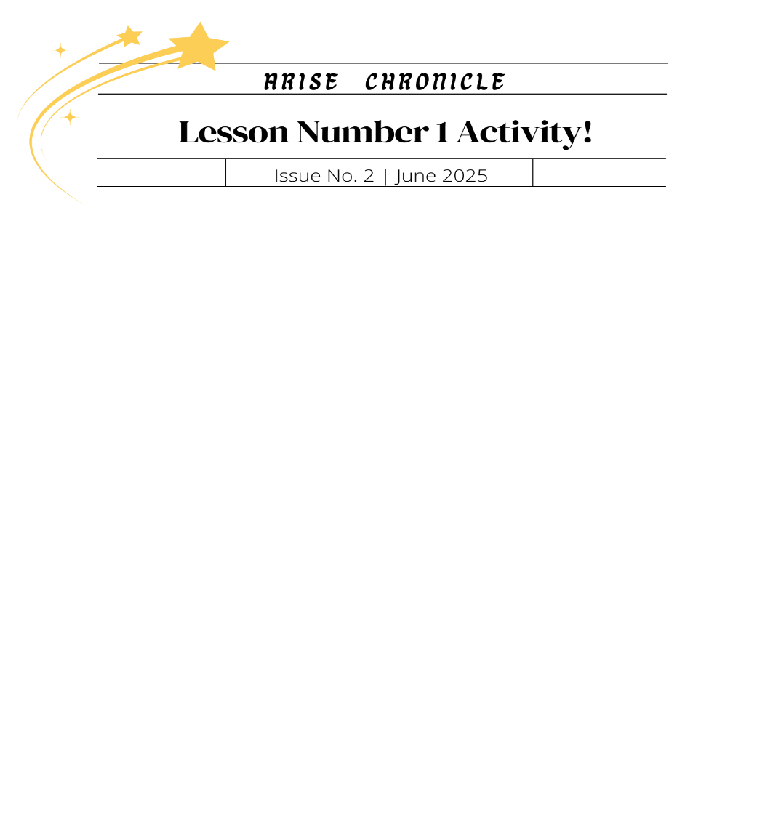
THE TRUTH ABOUT WORDS
James 1:26
1. What does this passage say about the tongue and our ability to control it?
______________________________________________________________________________
______________________________________________________________________________
James 3:5-8
1. What does this passage say about the tongue?
______________________________________________________________________________
______________________________________________________________________________
Proverbs 11:13
Proverbs 16:28
1. What do these passages say about gossip?
______________________________________________________________________________
______________________________________________________________________________
______________________________________________________________________________
2. Should we participate in gossip? Why or why not?
______________________________________________________________________________
______________________________________________________________________________
______________________________________________________________________________
Proverbs 12:18
Colossians 3:8
Romans 3:12-14
1. What do these passages say about our words?
______________________________________________________________________________
______________________________________________________________________________
______________________________________________________________________________
2. Should a Christian use filthy language? Why or why not?
______________________________________________________________________________
______________________________________________________________________________

3. Proverbs says our “reckless words” are a like a sword. What does that mean to you?
______________________________________________________________________________
______________________________________________________________________________

Proverbs 10:19
Ecclesiastes 5:2
Ecclesiastes 6:11
1. What do these Scriptures say about our words?
______________________________________________________________________________
______________________________________________________________________________
2. Why do you think the number of words we use matters?
______________________________________________________________________________
______________________________________________________________________________
Proverbs 12:18
Proverbs 16:21
1. What are some ways we can use our words for good?
______________________________________________________________________________
______________________________________________________________________________
Write down the struggle you have with words:
_______________________________________________________________________________________
_______________________________________________________________________________________
_______________________________________________________________________________________
_______________________________________________________________________________________
_______________________________________________________________________________________
_______________________________________________________________________________________
______________________________________________________________________________________

