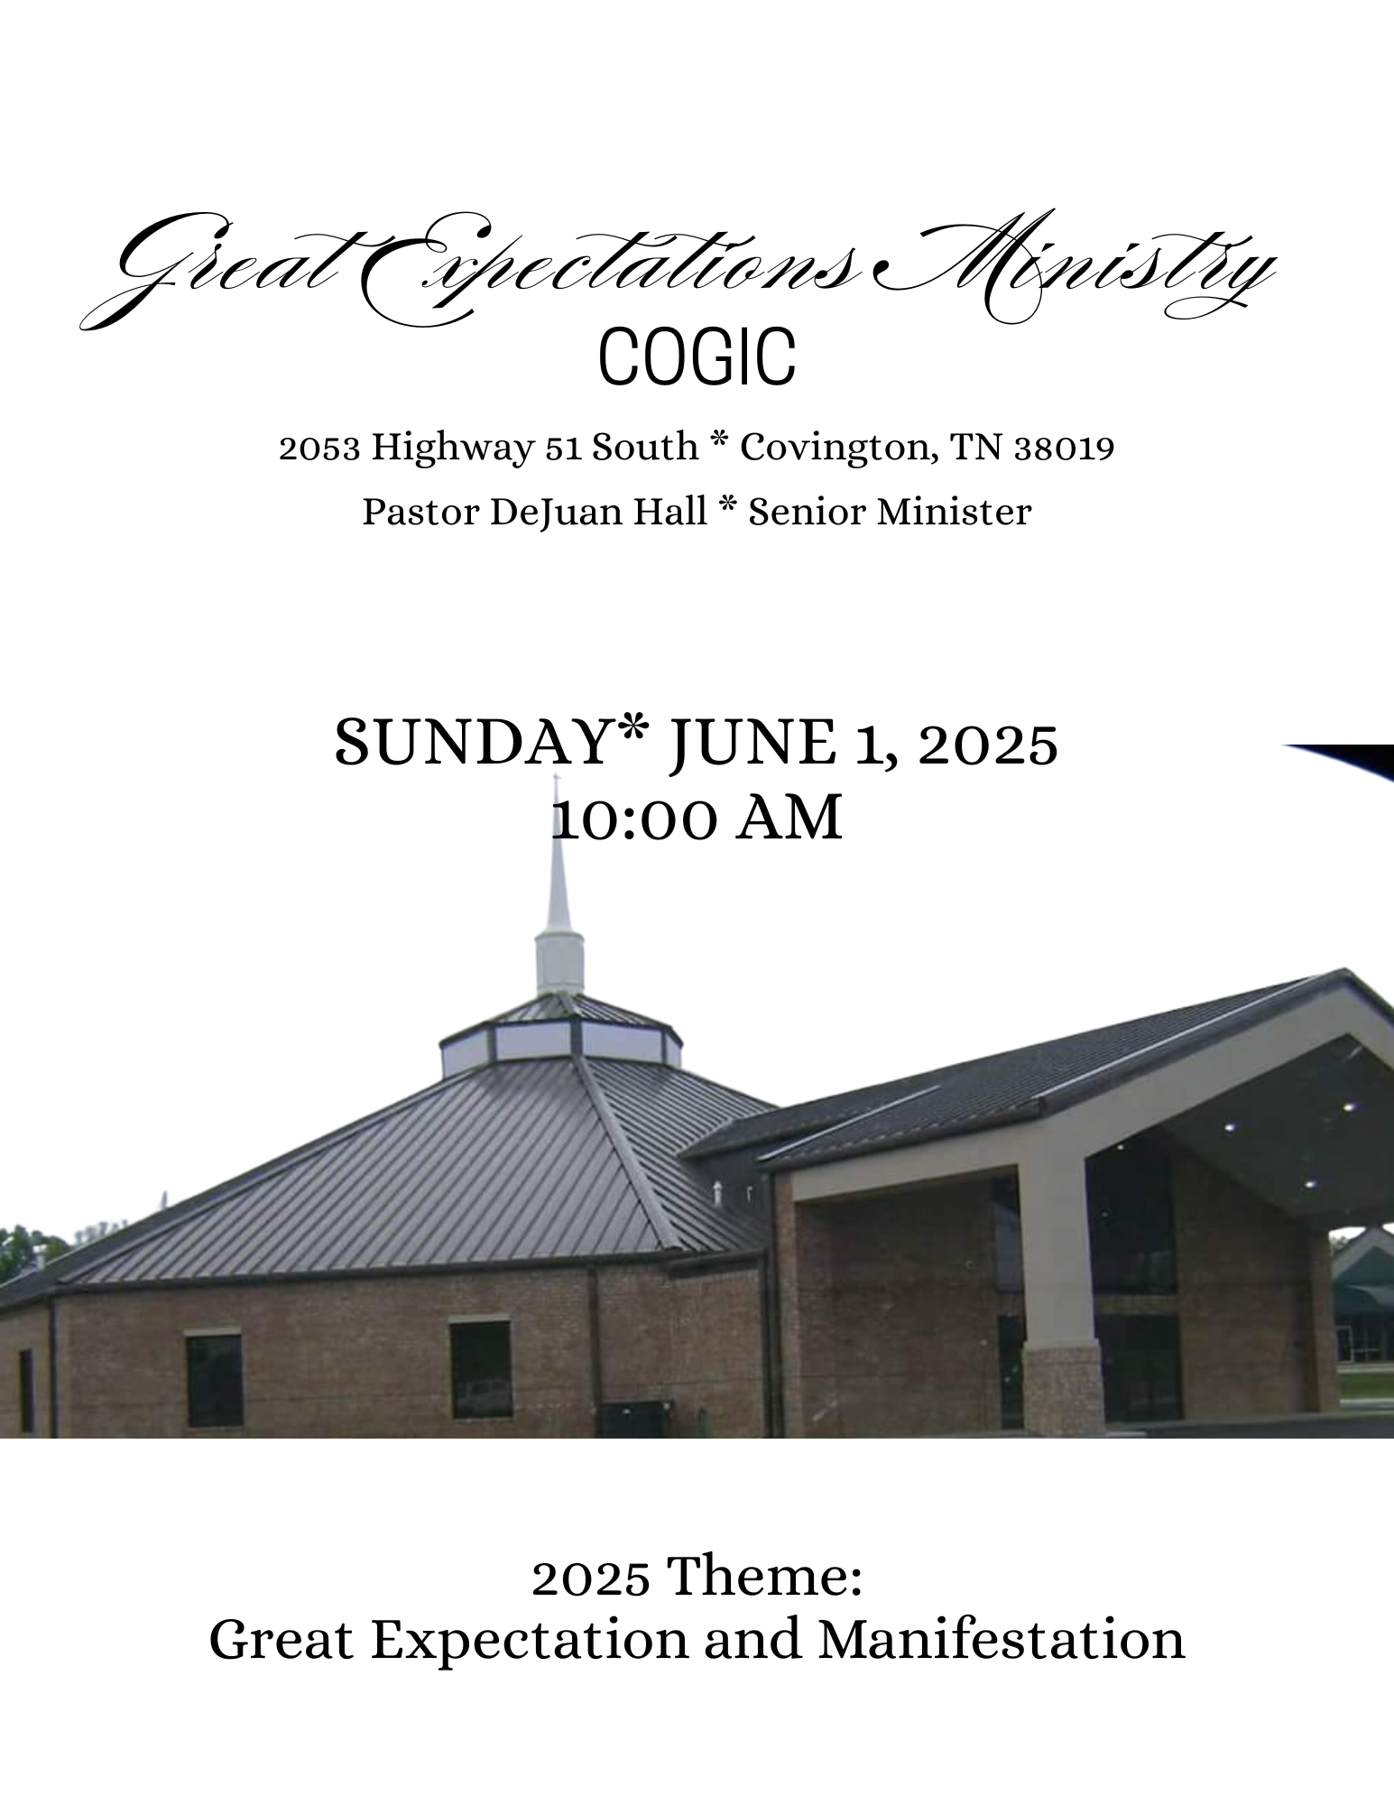
STUDENT RECOGNITION
We are excited to recognize our students for the accomplishments during the 2024-2025 academic school year. This special recognition will be Sunday, June 22, 2025, during the 10am celebration. Parents, please help us on this effort by going to our website and completing the form and packet on the site. The link is: https://greatexpectationsmincogic.com/scholarship/
Thanks for your help.


JUNE 2025 TEACHERS
SUNDAY SCHOOL
June 1 Eld. Richard Bateman
June 8 Deacon Ronald Hall
June 15 Missry Bobbie Topps
June 22 Minister Cletis Foster
June 29 Mother Eula Harris

BIBLE STUDY
June 3rd Special Men/Women Session: Missionary D. Hill-Davis & Pastor DeJuan Hall
June 10th Min Douglas Young
17th Vacation Bible School
24th Mother Eula Harris

THEME: RUN THE RACE (Hebrews 12:1-2)
June 17-20, 2025 * 6:00pm – 8:00pm
We hope you will join us for VBS 2025, sessions for children, teens, youth and adults. This is a great opportunity for you and your family to learn more about God in a friendly and exciting setting. We encourage you to take advantage the available curricula offered below, and don’t forget to enjoy the refreshments available each night. Please make plans to attend Tuesday through Friday and invite your friends!

Please take advantage of pre-registrations by visiting the link provided here: https://greatexpectationsmincogic.com/vbs/
You will be able to download the curricula for VBS, as well.


JUNE BIRTHDAYS
Minister DeRobert Adams 02
Deacon Robert Hall 07
Draden Burnett 11
Sister Darlene Catron 22

The Worship Experience
*Please stand where denoted

*Call to Worship Deacon Stephen Hall
📖 Hebrews 12:28 (NLT)
Since we are receiving a Kingdom that is unshakable,
let us be thankful and please God by worshiping Him
with holy fear and awe.

*Prayer Deacon Robert Hall
Praise and Worship GEM Praise Team
Welcome and Observations Sister Sherri Burnett

Offertory Scripture and Prayer Deacon Dalton Jenkins
🌾 2 Corinthians 9:6-7 "Remember this: Whoever sows sparingly will also reap sparingly, and whoever sows generously will also reap generously. Each one should give as he has decided in his heart—not reluctantly or under pressure—for God loves a cheerful giver."
Selection GEM Choir
Presentation of Messenger Elder Richard Bateman
The Messager Pastor DeJuan Hall
The Call to Discipleship
Remarks and Benediction Pastor DeJuan Hall

ANNIVERSARY
Bro & Sis Tom Burnett
June 24

Welcome to Great Expectations Ministries COGIC
Greetings in the name of our Lord and Savior, Jesus Christ!
We are honored that you have chosen to worship with us today. Whether this is your first time or you are a returning guest, we believe God has ordered your steps to be here. We are a church that walks by faith, stands on the Word of God, and lives with great expectation of His power and promises. It is our sincere prayer that today’s worship experience will uplift your spirit, encourage your heart, and strengthen your walk with the Lord. As we enter into praise, worship, and the Word, we invite you to open your heart to what God wants to do in your life. Don’t hold back—sing, pray, praise, and receive all that God has for you today! Once again, welcome to Great Expectations Ministries COGIC
PRAYER LIST
Pastor DeJuan Hall & Family
Elder Richard Bateman
Missionary Gwendolyn Hall
Sister Rosalind Doggett
Sis Yolanda Cunningham
Mrs. Angela Boddie- Alston
Pastor & Lady Charles Hayes

SERVICE OPPORTUNITIES
Monday Noonday Prayer 12:00 pm
Tuesday Bible Study 7:00 pm
Sunday:
Morning Prayer 8:45am
Sunday School 9:00am *Worship Experience 10 am

