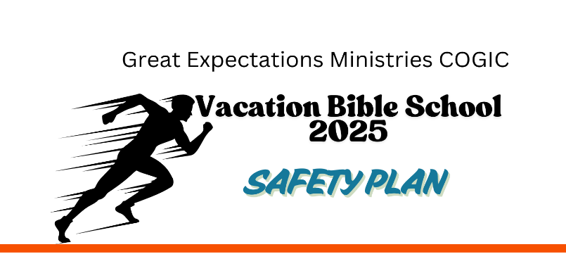
INSTRUCTORS, etc.
June 24-26, 2025
5pm – 8pm

SESSIONS | LEAD TEACHERS | TEACHER ASSISTANTS | HELPS
Married Breakout Sessions | Pastor Dejuan Hall | Lady Tamara Hall | Worship Team | DeRobert Adams  Amari Whitley  Kendall Burnett
Singles Breakout Sessions | Diane Robinson | Gwen Hall | Activity Team | Missy Foster  Robin Cochran  Kesha Bonds
Preteens & Youth Breakout Sessions  Ages 12-17 | Missy Foster | LaKesha Bonds  Robin Cochran | Registration Table Attendances | LaToja Flowers  Juanita Currie  Delphine Jenkins
Young Adults Breakout Sessions | Bobbie Topps | Joseph Burnett | Food/Snacks Team | Debra Adams  Joyce Toomes  Edith Diane Edwards  LaToja Flowers
Children 11 and younger | Sherri Burnett | DeRobert Adams | Van Drivers
 |  |  | Public Service Announcements | Gwen Hall  Evelyn Hall  Dorothy Hill-Davis
 |  |  | Cleaning Team | Dalton Jenkins  Debra Adams  Joyce Toomes  Stephen Hall

