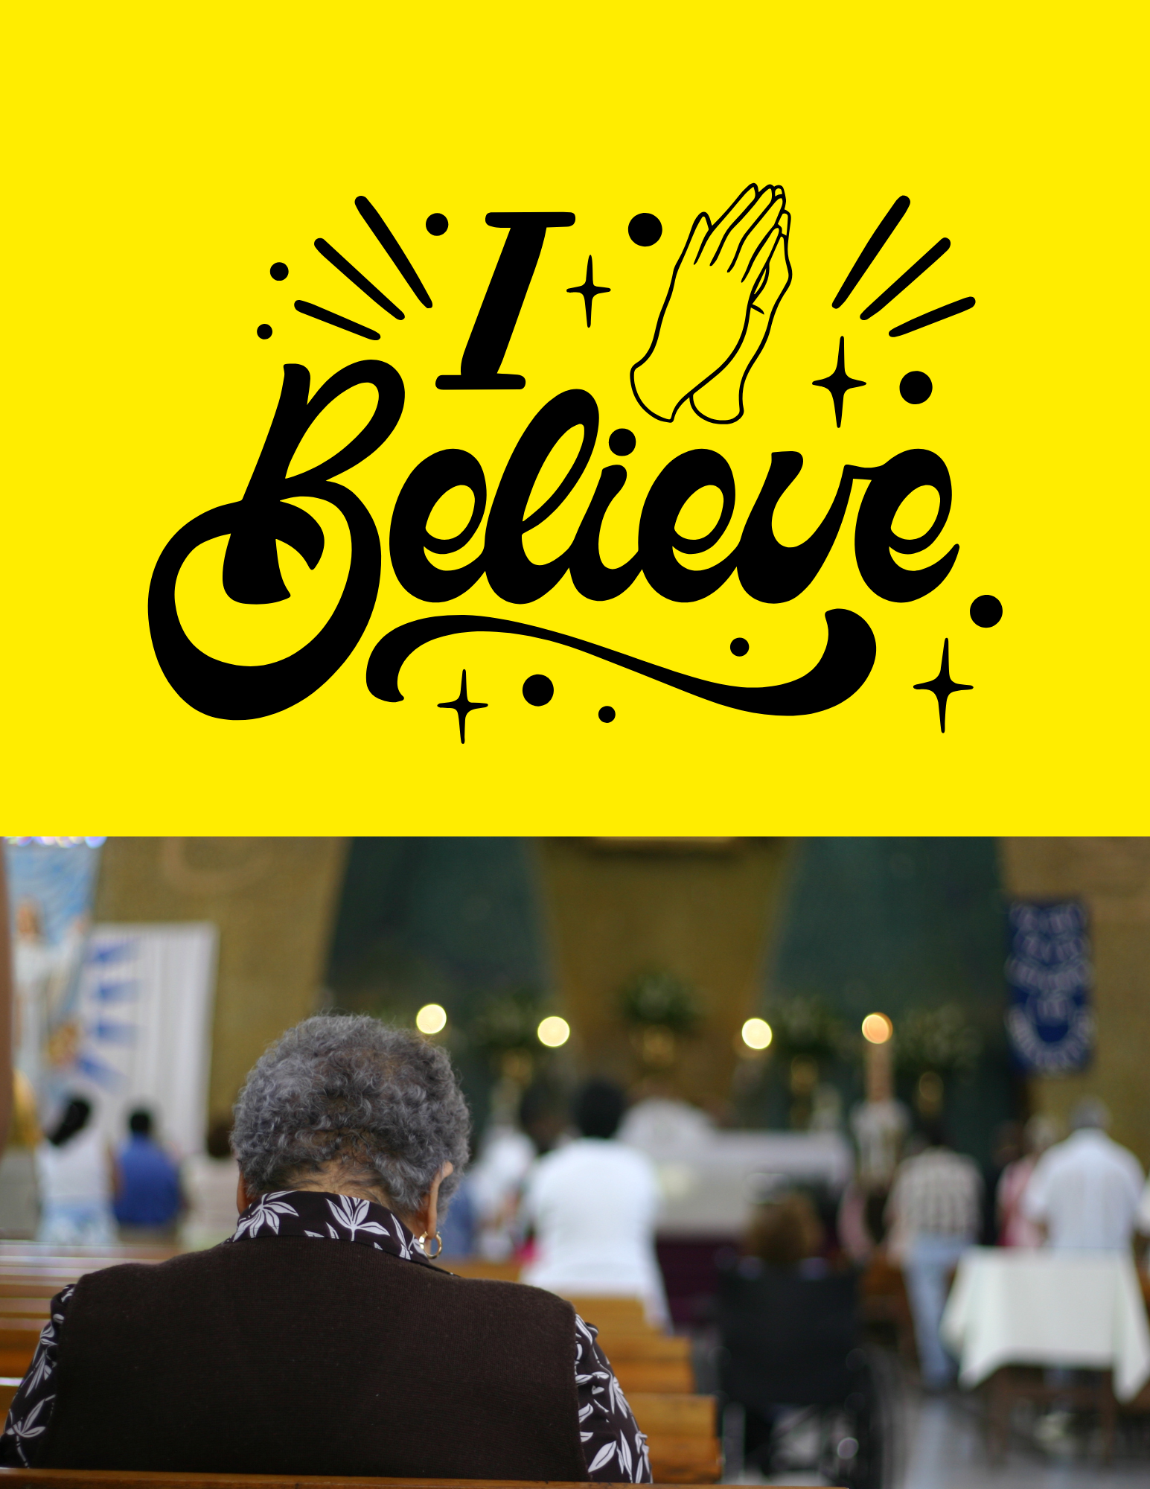

Lesson #1 How to Grow Spiritually

In this lesson you will learn:

• Repentance versus regret

• How growth happens

• How to stay free in Christ

Now that you are saved, we now need to talk about how to grow in your faith to avoid falling back into much of the lifestyle lived before you accepted Christ.

When we talk about God forgiving us of our sin what exactly does that mean? Did we repent of our sin because we had to, and how did we actually receive that forgiveness?

Is there a difference between repentance and regret we feel for our sin?

Repentance is what we did when we turned from our sin. The word repentance means to make a complete 180 degree turn towards God and away from sin. Real repentance is agreeing with God that all wrongdoing is sin.

Regret is feeling sorry for your sins rather than turning from them; feeling sorry you got caught. You chose to turn your life around when you were confronted with the truth.

You freely gave your heart and life to Christ, and he forgave you freely, this is where the growth process begins. This was done in and through the blood of Jesus. **Like anything else in life, living your Christian life takes work.**

Here are some verses to help you do that:

Develop a good habit of asking God to keep your mind and conscience free of guilt and unconfessed sins. 1 John 1:9 says: “If we confess our sins, he is faithful and just and will forgive us our sins and purify us from all unrighteousness.”

Now that you have accepted Jesus into your life you now have a choice whether you will control your sin nature (the part of you that wants to keep doing wrong). We have a sin nature that remains even after we are saved but we must learn to control our thoughts and desires. This is where God's Word comes in.

Galatians 5:16-18 says “So I say, live by the Spirit, and you will not gratify the desires of the sinful nature. For the sinful nature desires what is contrary to the Spirit, and the Spirit what is contrary to the sinful nature. They are in conflict with each other, so that you do not do what you want. But if you are led by the Spirit, you are not under law.” This means keeping God’s Word, no matter what.

Giving God control over our lives is key. We must give Him control over the sinful patterns in our lives, so we stay FREE from the control of sin. Growth begins when we stay faithful and obey God's Word in the midst of temptation. Romans 8:1 says “Therefore, there is now no condemnation for those who are in Christ Jesus,” 2 Corinthians 3:17 says “Now the Lord is the Spirit, and where the Spirit of the Lord is, there is freedom.”

Genuine Conversion means a change in our attitude towards sin. Growth in Obedience Growing in our faith takes work along with a strong relationship, obedience and trust in God. Growth Happens When:

1. We search the scriptures daily to learn what God has for us, and has done in us. The Bible is full of theology and doctrinal teachings. We must learn the main elements that keep us grounded. Hebrews 2:1 says “We must pay more careful attention, therefore, to what we have heard so that we do not drift away.” We need to retain what we have heard, remember it and apply it to our lives or it will do us no good.

2. We need to be faithful to who God calls us to be, in thought word and deed. Faithfulness means keeping our integrity, in all we do. Titus 2:8-9 says “In everything set them an example by doing what is good. In your teaching show integrity, seriousness and soundness of speech that cannot be condemned, so that those who oppose you may be ashamed because they have nothing bad to say about us.” I Timothy 4:12 says “Don’t let anyone look down on you because you are young, but set an example for the believers in speech, in life, in love, in faith, in purity.”

3. We must be "Doers of the Word” if we hear God's word and don't apply and obey it, then it becomes fruitless. When we learn to apply it, God will work deeply in our lives. James 1:22 says “Do not merely listen to the word and so deceive yourselves. Do what it says.”

4. We must die to our fleshly desires; the things we want must be second to what God wants. We must be willing to submit to God's plan as we read his Word and learn his will for us. Romans 12:1-2 says “Therefore, I urge you, brothers, in view of God’s mercy, to offer your bodies as living sacrifices, holy and pleasing to God – this is your spiritual act of worship. Do not conform any longer to the pattern of this world but be transformed by the renewing of your mind. Then you will be able to test and approve what God’s will is – his good, pleasing and perfect will.”

5. Prayer is a communication line to God. We must develop a daily prayer time that focuses on God. We must learn to talk to God, listen to God, and hear his voice. I Thessalonians 5:17 says “pray continually” James 5:13-17 says “Is any one of you in trouble? He should pray. Is anyone happy? Let him sing songs of praise. Is any one of you sick? He should call the elders of the church to pray over him and anoint him with oil in the name of the Lord. And the prayer offered in faith will make the sick person well; the Lord will raise him up. If he has sinned, he will be forgiven. Therefore, confess your sins to each other and pray for each other so that you may be healed. The prayer of a righteous man is powerful and effective.”

6. Evangelism. We must be about our Father’s business, telling others about the Gospel message. He came to save the world from sin. John 3:16 says “For God so loved the world that he gave his one and only Son, that whoever be believes in him shall not perish but have eternal life.” We need to go and make disciples of all nations as he commanded us to do. Matthew 28:19-20 says “Therefore go and make disciples of all nations, baptizing them in the name of the Father and of the Son and of the Spirit, and teaching them to obey everything I have commanded you. And surely, I am with you always, to the very end of the age.”

7. Church. We must be faithful to attend the house of worship to grow up in our faith. Romans 10:17 says “Consequently, faith comes from hearing the message, and the message is heard through the word of Christ.”

We must be faithful to meet together with others as it strengthens us spiritually. Hebrews 10:25 says “Let us not give up meeting together, as some are in the habit of doing, but let us encourage one another – and all the more as you see the Day approaching”.

Remember how to stay free in Christ:

ϖ Resist the devil. His plan for you is to rob, kill and destroy your life.

ϖ Renounce. We need to renounce our sin turn from it and be healed.

ϖ Confess. If we confess our sin and are quick to turn from it, we will learn to live victoriously.

ϖ Forgive. We need to confess our sins and ask God to forgive us and those that wrong us

Questions for you about this lesson

Please look up the following verses in your Bible

1. What does it say that we should live on? Read: Matthew 4:4

2. What does Jesus say about the Word of God? Read: John17:17

3. What do say that the scriptures do for us? Read: 2 Timothy 3:15-17

4. Why is it very important to memorize the Bible? What is to be gained in doing so? Read: Psalm 119:9-16

5. What reason does Peter give in his Book to read the Bible? Read: 1 Peter 2:2-3

6. What is God's desire is for everyone? Read: 2 Peter 3:9

7. What does the Gospel of Mark say that Jesus came preaching? Read: Mark 1:15 8. How did Peter conclude his first sermon? Read: Acts 2:38

9. How can people be recovered from the snare of the Devil? Read: James 4:7 and: 2 Timothy 2:23-26