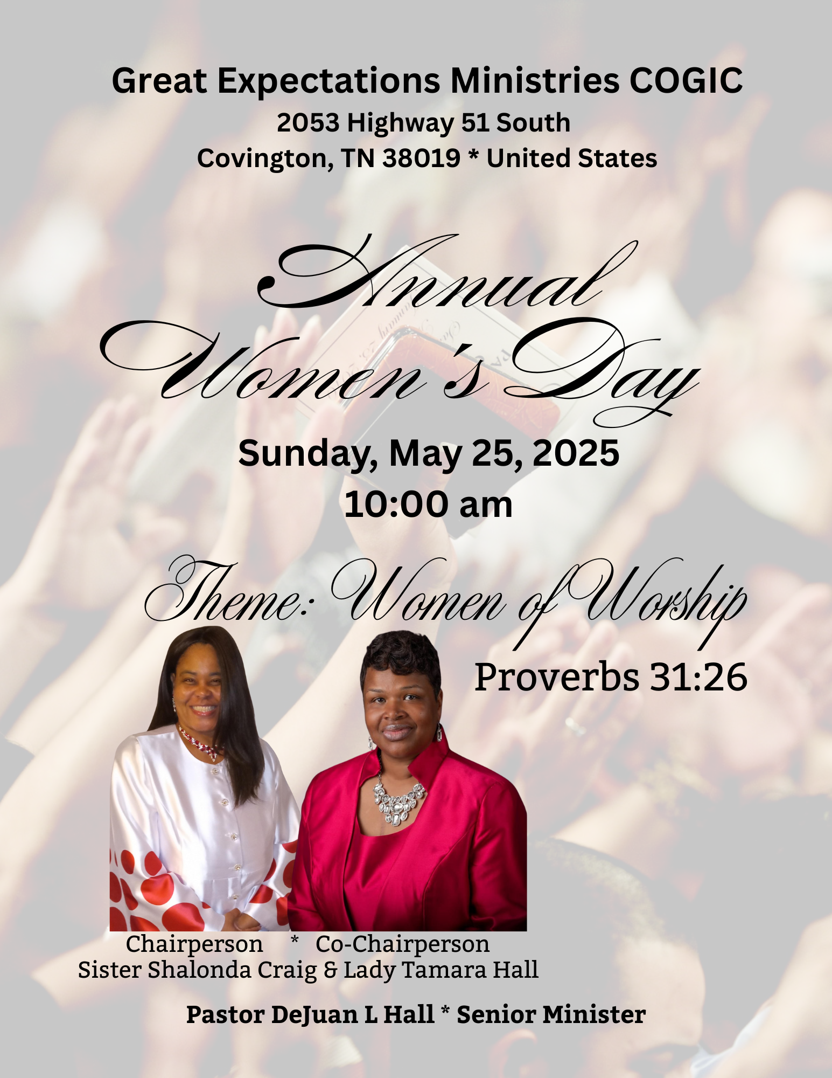

WORSHIP EXPERIENCE

***Facilitator: Sis. Delphine Jenkins***

The Call to Worship Sis. Jacqueline Young

Prayer Sis. Darlene Catron

Scripture Reading (Luke 8:48) Sister Edith D. Edwards (Proverbs 31:26) Sis. Cherlynn Seals

Welcome & Occasion Min. Diane Robinson

Praise and Worship GEM Choir (Women of Worship Choir)

Announcements Missionary Gwendolyn Hall

***Ministry of Giving***

Sis. Evelyn Hall

Sis. Robin Cochran, Sis Lisa Bernard Sis. Barbara Love, and  Sis. Joyce Toomes

Poem: A Woman in Prayer Missionary  Dorothy Hill-Davis

Selection GEM Choir (Women of Worship Choir)

Introduction of Speaker #1 Sis. Florence Fields

The Word of God Sis. Shalonda Craig

Introduction of Speaker #2 Missionary Bobbie Topps

The Word of God First Lady Tamara Hall

 Call to Discipleship Mother Eula Harris

***Special Presentations***

Sis. Juanita Currie,  Sis. Susan Bateman, Sis. Sherri Burnett

Gift Basket Darlene Catron

Words of Gratitude

Chairperson - Sis. Shalonda Craig & Co-Chairperson- First Lady Tamara Hall

 Remarks and Benediction Pastor DeJuan Hall



**MAY**

1st Mother Gloria Reed

4th Sis. Deirdre Burnett

5th Mother Eula Harris

6th Missionary Dorothy Hill-Davis

7th Sister Angela Edwards

16th Sister Nehemiah Taylor

18th Brother Cameron Hall

24th Sister Sherri Alston-Burnett

25th Elder Richard Bateman

27th Brother Jaylen Hall

28th Sister Lisa Bernard

31st Brother Tom Burnett



**PRAYER LIST**

Missionary Gwendolyn Hall

Sister Rosalind Doggett

Sister Yolanda Cunningham

Minister Diane Robinson

Deacon Jerry Hall

Missionary Dorothy Hill-Davis

Mr. Robert Adams Jr

Mr. Pervis Payne

Mother Mabel Smith

Supt. Carl Payne

Draden Burnett

Mrs. Gracie M Somerville’s family

Mrs. Joann Burton & Family

The Hayslett Family

The Tipton Family

Mrs. Angela Boddie- Alston

**JUNE BIRTHDAYS**

Minister DeRobert Adams 02

Deacon Robert Hall 07

Draden Burnett 11

Sister Darlene Catron 22

**ANNIVERSARY**

Bro & Sis Tom Burnett June 24

**SERVICE OPPORTUNITIES**

Monday Noonday Prayer 12:00 pm

Tuesday Bible Study 7:00 pm

Sunday:

Morning Prayer 8:45 am

Sunday School 9:00 am

Worship Experience 10:00 am

**Join Us!**



THEME: RUN THE RACE (Hebrews 12:1-2)

June 17-20, 2025 * 6:00pm – 8:00pm

We hope you will join us for VBS 2025, sessions for children, teens, youth and adults. This is a great opportunity for you and your family to learn more about God in a friendly and exciting setting. We encourage you to take advantage the available curricula offered below, and don’t forget to enjoy the refreshments available each night. Please make plans to attend Tuesday through Friday and invite your friends!

Please take advantage of pre-registrations by visiting the link provided here: <https://greatexpectationsmincogic.com/vbs/>

You will be able to download the curricula for VBS, as well.

**JUNE 2025 TEACHERS**

**SUNDAY SCHOOL**

June 1 Eld. Richard Bateman

June 8 Deacon Ronald Hall

June 15 Missry Bobbie Topps

June 22 Minister Cletis Foster

June 29 Mother Eula Harris

**BIBLE STUDY**

**May 27th** Minister Douglas Young

June 3rd Special Men/Women Session

Missionary D. Hill-Davis & Pastor DeJuan Hall

June 10th Min Douglas Young

17th Vacation Bible School

24th Mother Eula Harris

***Congratulations to our 2025 graduates.***

Mr. Kylus Camell Stokes – Ripley High School

Mr. TèShawn Orlando Craig- Tennessee Connections Academy

Ms. Mya Jenae Craig – Covington High School

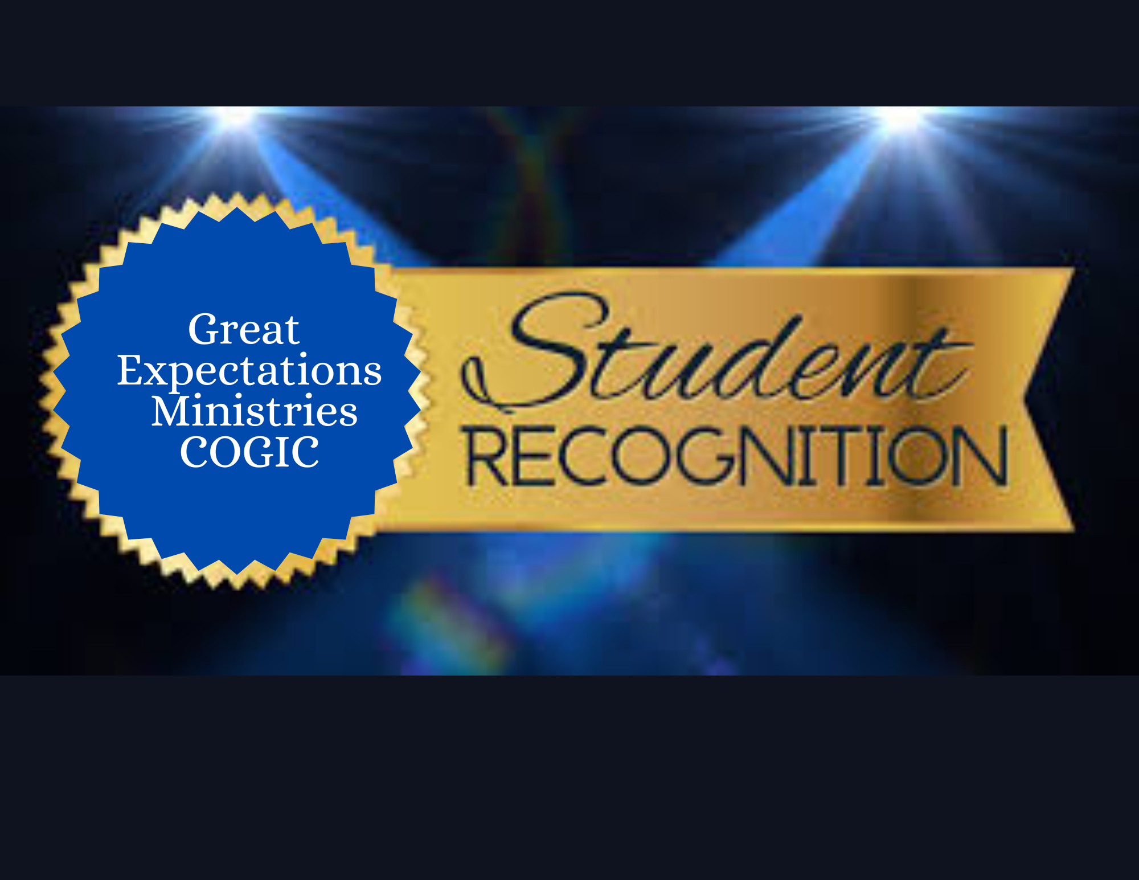

*Education is for improving the lives of others and for leaving your community and world better than you found it.*

*– Marian Wright Edelman*

We are excited to recognize our students for the accomplishments during the 2024-2025 academic school year. This special recognition will be Sunday, June 22, 2025, during the 10am celebration. Parents, please help us on this effort by going to our website and completing the form and packet on the site. The link is: <https://greatexpectationsmincogic.com/scholarship/>

Thanks for your help.



**IMPORTANT MEETING**

We will have our VBS meeting via zoom, Friday, May 30th at 7:00pm. The following people are asked to meet: Lady Tamara Hall, Gwen Hall, Diane Robinson, Sherri Burnett, Bobbie Topps, Joe Burnett, Missy Foster, Robin Cochran, LaKesha Bonds, Amari Whitley, Kendall Burnett, Rosalind Doggett, Joyce Toomes Juanita Currie, Debra Adams, Evelyn Hall, Edith Diane Edwards,, LaToja Flowers, Sharon Blue, Stephen Hall

**Zoom Info: ID: 858 4470 8536 * Phone: 1-301-715-8592**

**The Truth About Self-Control**

Lesson 4 * June 22nd

**The Truth About Money**

Lesson 5 * June 29th

**ARISE**

(Achiever * Resilient * Inspire * Selg-discipline * Excellence)

Children and Preteens are encouraged to join our classes at 9:00am each Sunday. These are NOT your typical classes! Come, and See….

**Sunday School Ministry's**

theme for JUNE is TRUTH OR DARE

Our Aim: *To be a ministry that promotes WHO Christ is and to make HIM known.*

**The Truth About Words**

LESSON 1* June 1st

**Truth About Being Nice**

Lesson 2 * June 8

**Living the Truth**

Lesson 3 * June 15th

