**LESSON #3**

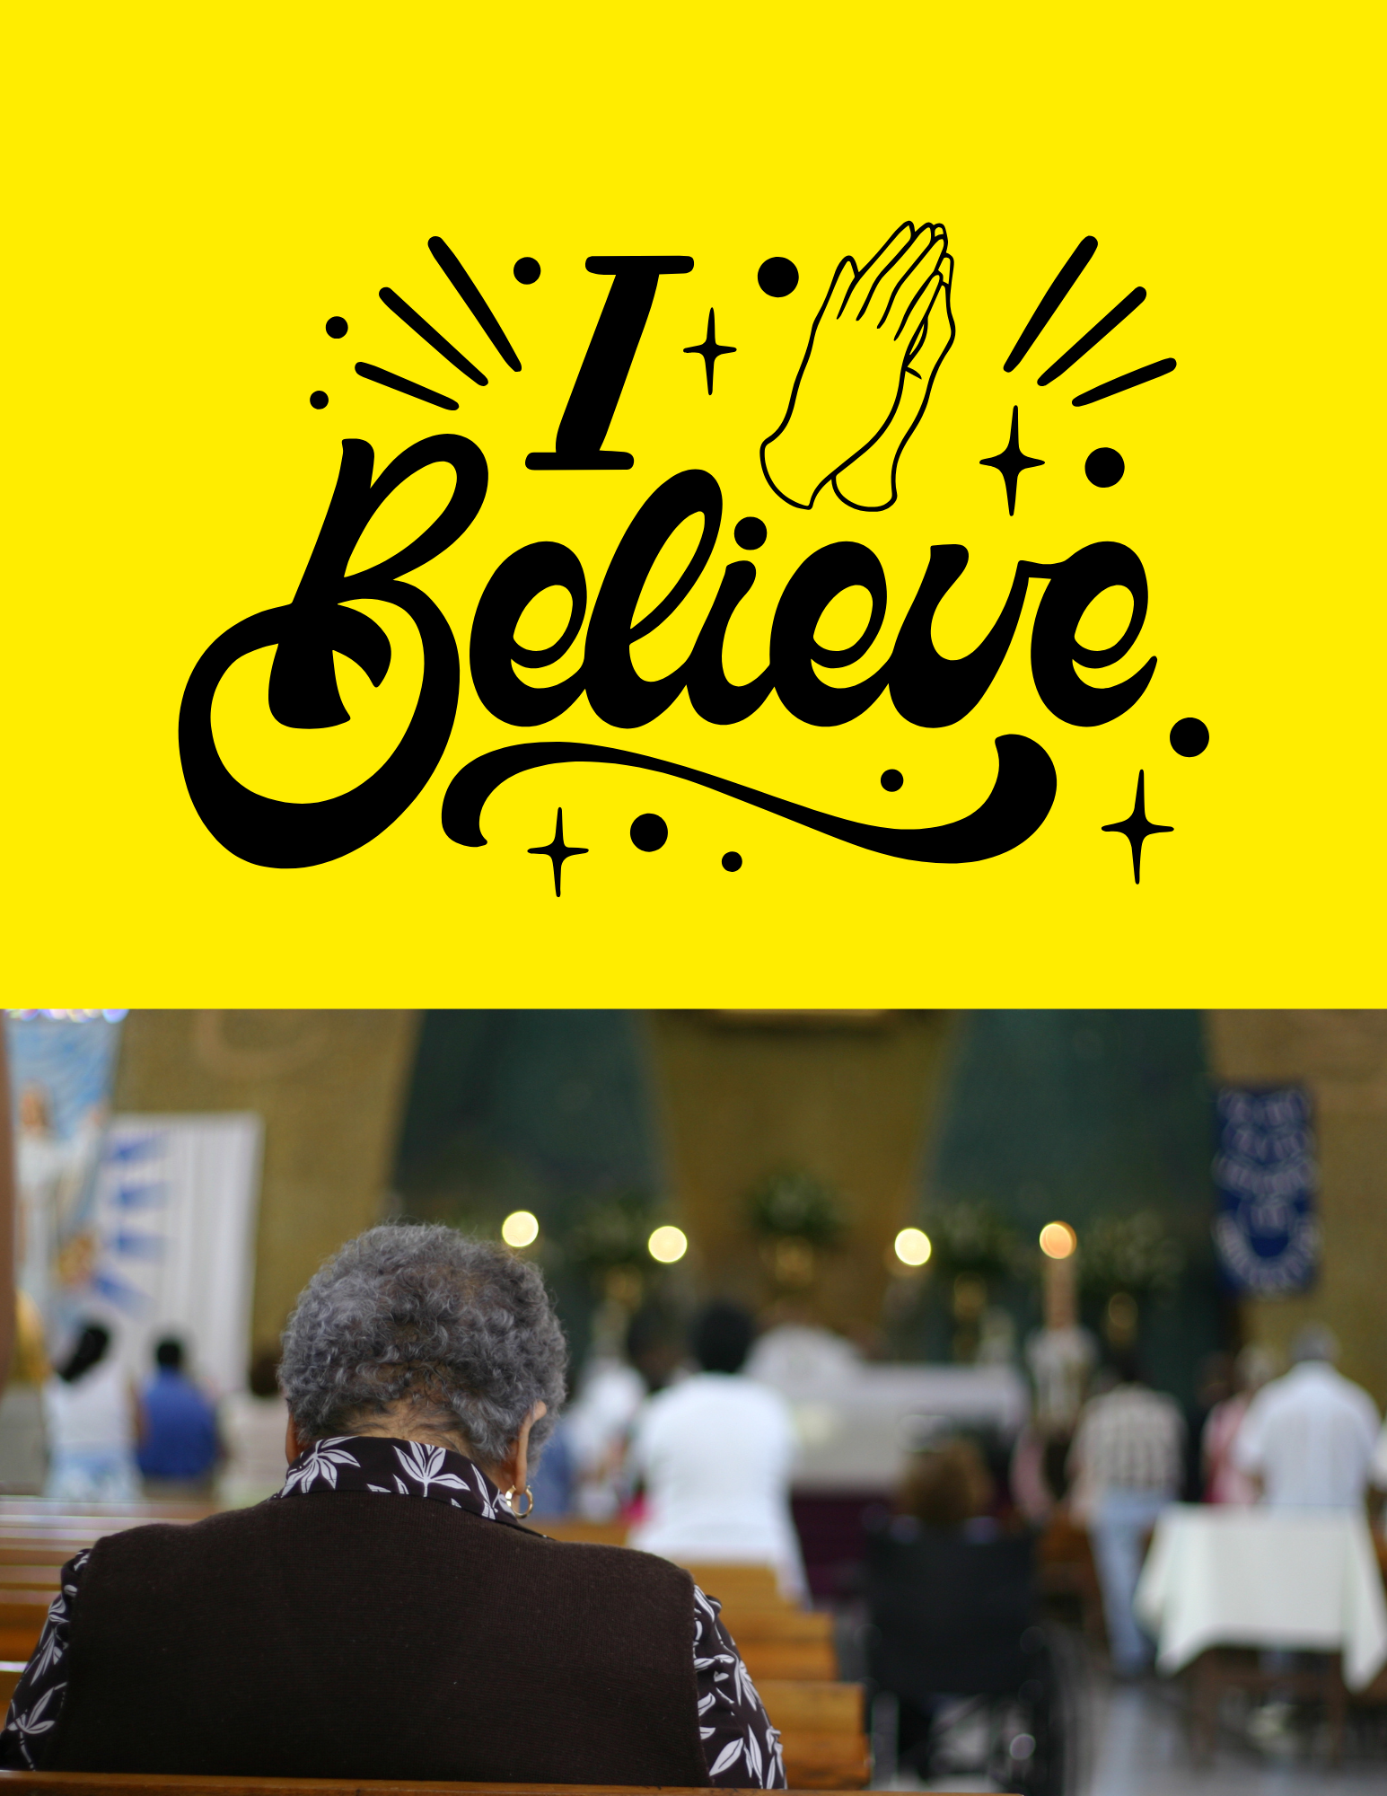

**Lesson #3 Knowing and Learning to Do the Will of God**

In this lesson you will learn:

• What the Bible says about God’s perfect will

• Keys to follow to obey God’s will

• Areas of caution when considering God’s will

What is the will of God and how do we understand it?

Learning to do God’s will can be a lifelong task for the child of God. Understanding how God directs us is not always easy. There are many ways we can develop our skills to walk closely with God and try to make sense of his will for us.

Get alone with God Getting alone with God is the best way God can speak directly to you. Prayer is the best way to hear and learn Gods guidance. Practice speaking and listening to God daily in prayer.

¬ Learn to distinguish the different voices that speak to us Building a prayer life allows us to enter God’s very presence where all peace or peace of mind and serenity dwell. Below are three types of voices we must learn to distinguish as we develop our relationship with God:

1. The World Those unknown voices around us telling us to go here and there and busy our minds.

2. Flesh/Our Own Voice Things we dwell on or think about that are not of God.

3. The Devil The Enemy putting thoughts in our minds.

¬ God wants you to know his perfect will through his perfect Word The best way to learn God's will is to practice obeying his Word. Practicing basic principles of Scripture based on verses like Romans 12:2 “Do not conform any longer to the pattern of this world but be transformed by the renewing of your mind. Then you will be able to test and approve what God’s will is – his good, pleasing and perfect will.” Read the Word, obey what it says. Or in other words, live it. James 1:22 says: “Do not merely listen to the word and so deceive yourselves. Do what is says.”

¬ Always tell God what is on your heart, laying everything before him Sometimes the option that goes the farthest in your spirit prayerfully is the most likely the will of God. All that is done through confession brings freedom and openness to God. Proverbs 28:13 says: “He who conceals his sins does not prosper, but whoever confesses and renounces them finds mercy.”

¬ Always read God's Word first and foremost for direction Read verses that deal especially and directly with circumstances you face. For example, if you are suffering from illness it helps to refer to verses on sickness. Read: Isaiah 53:5, Jeremiah 33:6, Psalm 107:20, Isaiah 41:10

¬ Guided by Peace God’s Word tells us he gives perfect peace. Isaiah 26:3 says: “You will keep in perfect peace him whose mind is steadfast, because he trusts in you.” Always seek out an answer from God’s word and wait for him to confirm it by prayer, with his perfect peace. This will ensure that you’ve made the right decision. Note: Sometimes we must be content to wait for God’s perfect timing and how the future will unfold. It often takes time to understand why God acts as he does.

**Often, guidance is sometimes not sought or asked for**

God can give us direction or leading through sources we don’t expect. It is often a channel or source of direction we hadn’t thought of or realized was there. For example, a phone call from an unlikely person, a message from someone we did not know previously.

**God will Guide you through the natural processes of your mind**

This is one reason why you need to live a victorious life in the Spirit avoiding sin at any cost. Romans 12:1-2 says: “Therefore, I urge you, brothers, in view of God’s mercy, to offer your bodies as living sacrifices, holy and pleasing to God – this is your spiritual act of worship. Do not conform any longer to the pattern of this world but be transformed by the renewing of your mind. Then you will be able to test and approve what God’s will is – his good, pleasing and perfect will.”

These verses hold the key to understanding this truth. It’s a process of conforming and transforming our minds and thoughts to line up with God’s. This becomes an ongoing process for the rest of our lives. The mind must continue to be renewed in the Word to keep the mind of Christ. The battle begins and ends in the mind. Read Romans 8:5-12.

**Here are some keys to follow when trying to obey God’s will**

**Always reflect upon where God brought you from and what he has done for you, remembering all his faithfulness**. It builds faith and keeps us on the straight path. Hebrews 11:1 says: “Now faith is being sure of what we hop for and certain of what we do not see.” It is often easier to see what he has done by looking back on his faithfulness. Live a Spirit filled life and God’s will and his hand will be more easily seen and understood.

It is vital we learn to live by the prompting of the Holy Spirit. Galatians 5:16 says: “So I say, live by the Spirit, and you will not gratify the desires of the sinful nature.”

Don’t try to understand the mysteries of life such as pain and suffering, disabilities or accidents. Walk slowly and steadily, daily obeying God in all you do. Keep a clear conscience, free from condemnation and guilt. A clear conscience will enable you to think more freely and overcome attacks from the devil more quickly

**Important to Note:**

If someone tells you something that they think is from God for your life and is a word of wisdom, make sure it lines up with what God has already told you in prayer and from his Word. It should never be new information God has not introduced for your life or spoken into your life.

There are some “gray areas” to avoid in approaching God’s will for your life. Ask yourself these questions:

1. Does what I'm doing or about to do bring glory to God? 1 Corinthians 10:31 says: “So whether you eat or drink or whatever you do, do it all for the glory of God.”

2. Does it benefit God and others? 1 Corinthians 10:23 says: “Everything is permissible” – but not everything is beneficial. “Everything is permissible” – but not everything is constructive.”

3. Does it display a Christ-like Character?

4. Does it have a tendency to enslave me in sin? Does it bring bondage to my Christian walk or does it strengthen me? 1 Corinthians 6:12 says: “Everything is permissible for me” – but not everything is beneficial. “Everything is permissible for me” – but I will not be mastered by anything.”

5. Will it guard my life against temptation? Matthew 6:13, the Lord's prayer, says: “And lead us not into temptation, but deliver us from the evil one.” Do you pray this?

6. Is what I do characteristic of worldly actions or those of the Father? Are my pleasures and entertainment good or bad if it were viewed by others of faith? Read 1 John 2:15, Hebrews 12:1

7. Do my decisions affect others or cause others to stumble around me? Read 1 Corinthians 8:13, Romans 13:10, Romans 14:16, 21-23

Obeying the will of God is a learning process and it takes a lifetime to achieve. As we walk daily in his presence, we must obey his Word. Focus on learning to listen to his voice in prayer and to those who help guide you through Scriptural advice from the Bible, such as church leadership and other experienced Christians we trust.

The Bible says in Proverbs 27:17 says: “As iron sharpens iron, so one man sharpens another.” Iron sharpens iron means that others who have that edge of wisdom for you will help to strengthen you in that moment you need direction and encouragement.

**New believers - Lessons created by SoulsforChristministries.org Bible verses taken from the New International Version**