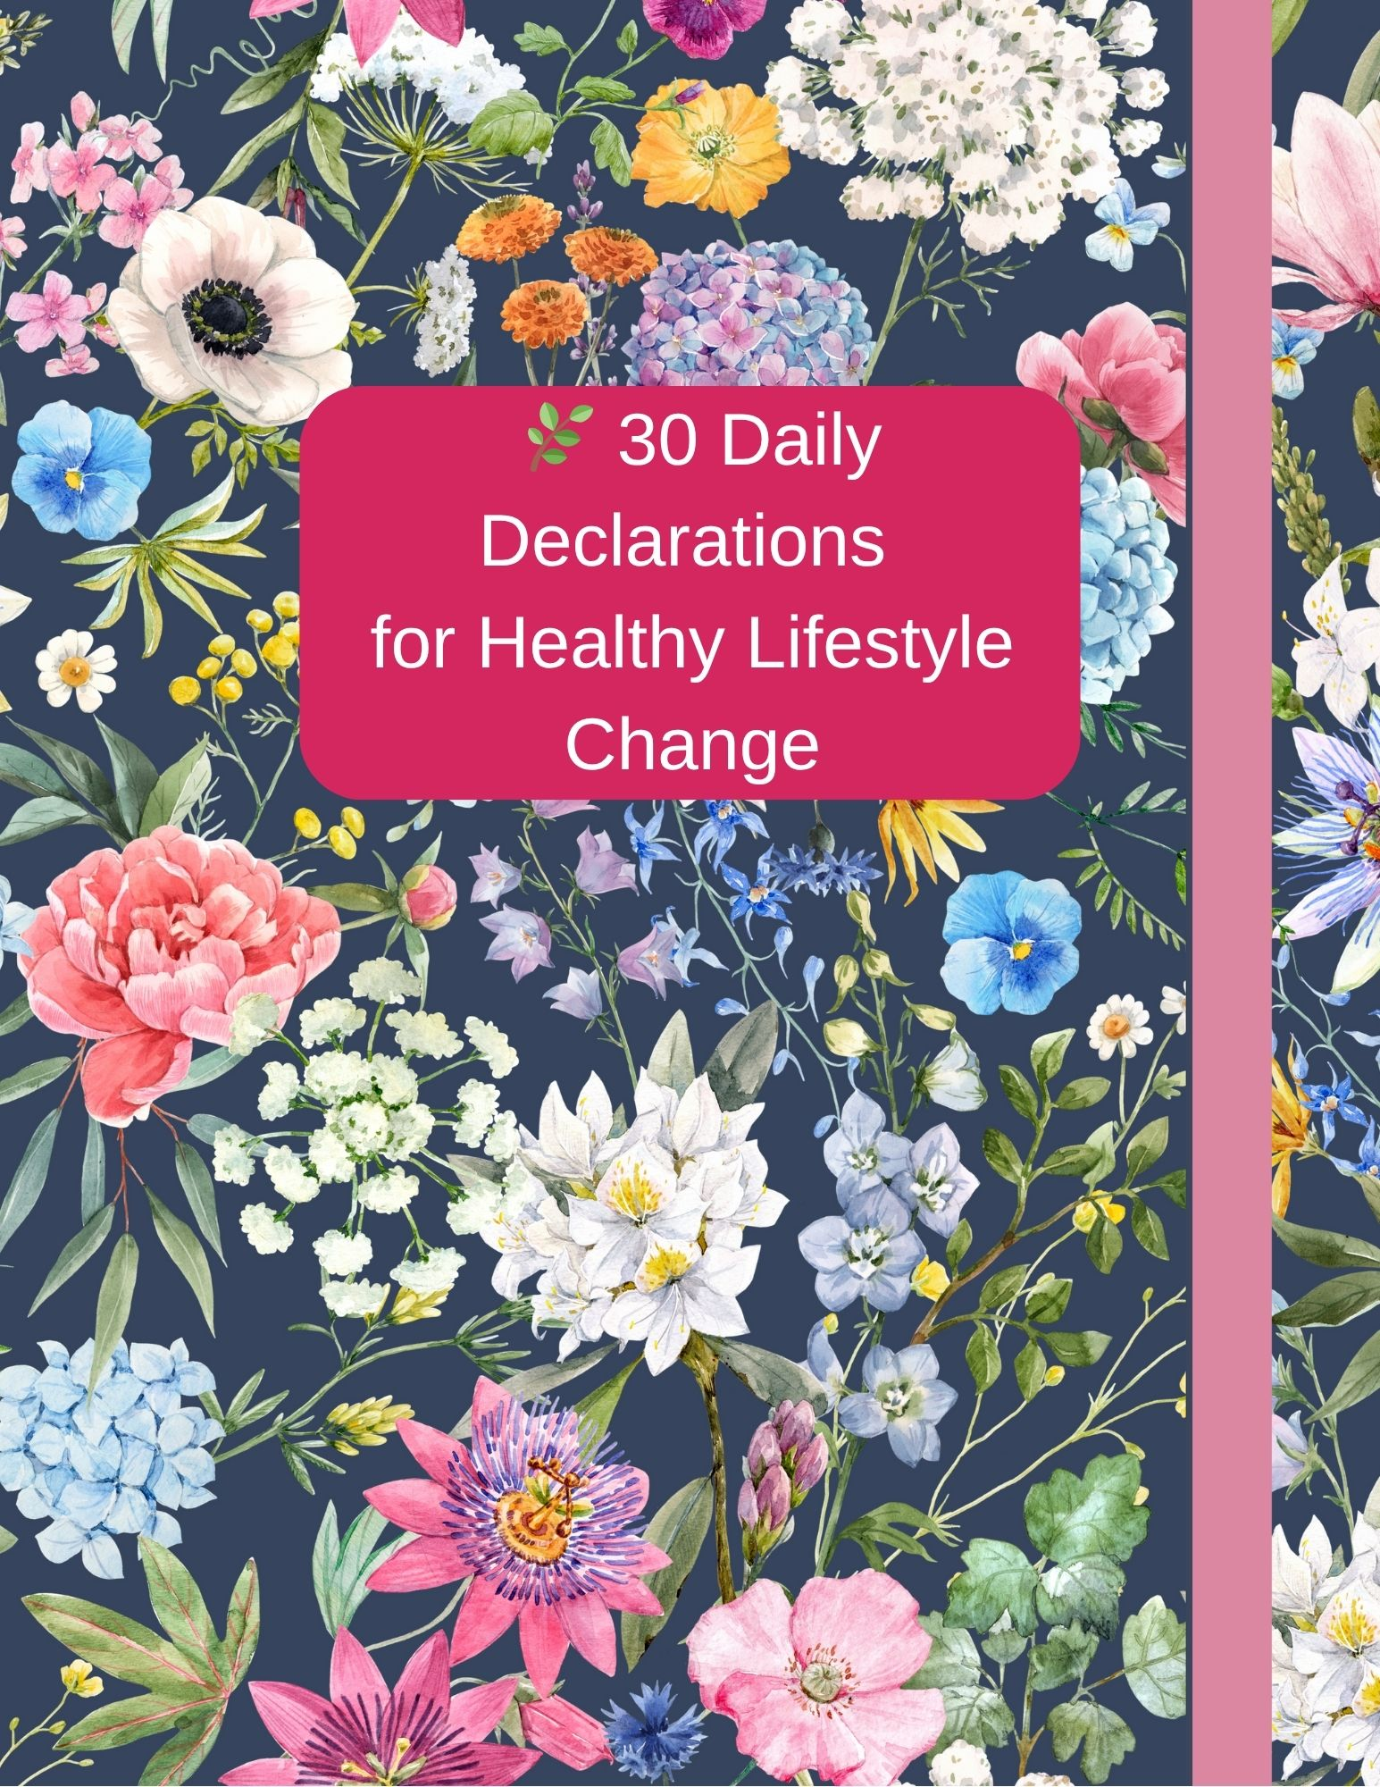

📖 Why Daily Declarations Matter
Speaking God’s Truth Over Your Life Every Day

🔹 What Are Declarations?
Declarations are faith-filled statements spoken aloud that affirm what God has already said in His Word. They are not “wishing” or “manifesting” in human strength—but are bold, biblical truths declared in agreement with God's promises.

🔹 Why Should I Declare God’s Word Daily?
1. To Renew My Mind
God’s Word transforms how I think.
📖 “Do not conform to the pattern of this world, but be transformed by the renewing of your mind.” – Romans 12:2

2. To Build My Faith
Faith is built by repeatedly hearing and speaking the Word.
📖 “Faith comes by hearing, and hearing by the word of God.” – Romans 10:17

3. To Stand Against the Enemy’s Lies
Declarations help me fight fear, doubt, and shame with truth.
📖 “Take the sword of the Spirit, which is the word of God.” – Ephesians 6:17
📖 “You will know the truth, and the truth will set you free.” – John 8:32

4. To Walk in Identity and Authority
When I speak who I am in Christ, I start to live like it.
📖 “As He is, so are we in this world.” – 1 John 4:17
📖 “The tongue has the power of life and death...” – Proverbs 18:21

5. To Agree with Heaven
My declarations align my heart and speech with God’s plan.
📖 “Your kingdom come, your will be done, on earth as it is in heaven.” – Matthew 6:10

Daily Declarations for Healthy Lifestyle Change specifically crafted for the Women's Ministry of Great Expectations Ministries COGIC. These declarations blend faith, discipline, and personal empowerment with biblical truth, making them ideal for personal reflection, group prayer, or ministry devotionals.

🌿 30 Daily Declarations for Healthy Lifestyle Change
Great Expectations Ministries COGIC – Women’s Ministry

Day 1
I declare that my body is the temple of the Holy Spirit, and I will honor God by caring for it. (1 Corinthians 6:19-20)
________________________________________________________________________________________________________________________________________________________________________________________________________________________________________________________________________

Day 2
I declare that I am fearfully and wonderfully made. I choose to love myself as God loves me. (Psalm 139:14)
________________________________________________________________________________________________________________________________________________________________________________________________________________________________________________________________________

Day 3
I declare that I have divine strength to resist cravings that do not honor my health or God. (Philippians 4:13)
________________________________________________________________________________________________________________________________________________________________________________________________________________________________________________________________________

Day 4
I declare that the Holy Spirit leads me in every area of my life—including my health choices. (Galatians 5:22-23)
________________________________________________________________________________________________________________________________________________________________________________________________________________________________________________________________________

Day 5
I declare that I am no longer a slave to unhealthy habits. I walk in freedom.
(Romans 6:14)
________________________________________________________________________________________________________________________________________________________________________________________________________________________________________________________________________

Day 6
I declare that I will not grow weary in doing well; my healthy efforts will produce results. (Galatians 6:9)
________________________________________________________________________________________________________________________________________________________________________________________________________________________________________________________________________

Day 7
I declare that my mind is being renewed, and I choose thoughts that give life.
(Romans 12:2)
________________________________________________________________________________________________________________________________________________________________________________________________________________________________________________________________________

Day 8
I declare that I make wise choices about what I eat and how I care for my body.
(Proverbs 3:7-8)
________________________________________________________________________________________________________________________________________________________________________________________________________________________________________________________________________

Day 9
I declare that I walk in self-control and discipline daily. (Titus 2:11-12)
________________________________________________________________________________________________________________________________________________________________________________________________________________________________________________________________________
Day 10
I declare that I speak life over my health and body every day. (Proverbs 18:21)
________________________________________________________________________________________________________________________________________________________________________________________________________________________________________________________________________

Day 11
I declare that God satisfies my mouth with good things and renews my strength like the eagle. (Psalm 103:5)
________________________________________________________________________________________________________________________________________________________________________________________________________________________________________________________________________

Day 12
I declare that I will drink water for refreshment and nourishment, just as I thirst for God. (John 4:14)
________________________________________________________________________________________________________________________________________________________________________________________________________________________________________________________________________

Day 13
I declare that I exercise my body in gratitude, not guilt, honoring the life God gave me. (1 Timothy 4:8)
________________________________________________________________________________________________________________________________________________________________________________________________________________________________________________________________________

Day 14
I declare that I am equipped to endure, grow, and thrive on my healthy journey.
(Isaiah 40:31)
________________________________________________________________________________________________________________________________________________________________________________________________________________________________________________________________________

Day 15
I declare that my emotions do not control me; the peace of God rules my heart and appetite. (Colossians 3:15)
________________________________________________________________________________________________________________________________________________________________________________________________________________________________________________________________________

Day 16
I declare that I am not defined by the scale—I am defined by God's purpose in me.
(Jeremiah 29:11)
________________________________________________________________________________________________________________________________________________________________________________________________________________________________________________________________________

Day 17
I declare that I embrace rest, restoration, and rhythms that glorify God.
(Exodus 20:8-10)
________________________________________________________________________________________________________________________________________________________________________________________________________________________________________________________________________

Day 18
I declare that I am committed to long-term health, not temporary fixes.
(Ecclesiastes 7:8)
________________________________________________________________________________________________________________________________________________________________________________________________________________________________________________________________________

Day 19
I declare that I reject shame and comparison. I walk in grace and truth.
(Romans 8:1)
________________________________________________________________________________________________________________________________________________________________________________________________________________________________________________________________________

Day 20
I declare that the joy of the Lord is my strength on hard days. (Nehemiah 8:10)
________________________________________________________________________________________________________________________________________________________________________________________________________________________________________________________________________

Day 21
I declare that I am consistent, faithful, and empowered to make wise decisions.
(1 Corinthians 15:58)
________________________________________________________________________________________________________________________________________________________________________________________________________________________________________________________________________

Day 22
I declare that God gives me wisdom in grocery shopping, meal planning, and preparation. (James 1:5)
________________________________________________________________________________________________________________________________________________________________________________________________________________________________________________________________________

Day 23
I declare that I reject emotional eating and run to God as my comfort.
(Psalm 46:1)
________________________________________________________________________________________________________________________________________________________________________________________________________________________________________________________________________

Day 24
I declare that I enjoy the journey and celebrate every small victory.
(Zechariah 4:10)
________________________________________________________________________________________________________________________________________________________________________________________________________________________________________________________________________

Day 25
I declare that God’s grace is sufficient when I fall short. I begin again with confidence. (2 Corinthians 12:9)
________________________________________________________________________________________________________________________________________________________________________________________________________________________________________________________________________

Day 26
I declare that I model a healthy lifestyle for those I love and lead. (Titus 2:3-5)
________________________________________________________________________________________________________________________________________________________________________________________________________________________________________________________________________

Day 27
I declare that I walk in purpose, not pressure. I am on God’s timeline.
(Ecclesiastes 3:1)
________________________________________________________________________________________________________________________________________________________________________________________________________________________________________________________________________

Day 28
I declare that each day is a new opportunity to honor God with my health.
(Lamentations 3:22-23)
________________________________________________________________________________________________________________________________________________________________________________________________________________________________________________________________________

Day 29
I declare that I crave what is good, holy, and healing for my body and soul.
(Matthew 5:6)
________________________________________________________________________________________________________________________________________________________________________________________________________________________________________________________________________

Day 30
I declare that I am a Kingdom Woman walking in health, wholeness, and victory!
(3 John 1:2)
________________________________________________________________________________________________________________________________________________________________________________________________________________________________________________________________________

🙏 Reflection Questions:
- In what area of my life do I need to speak God’s truth more boldly?
- Are there any lies I’ve believed that I need to replace with declarations?
- What promise from God am I standing on today?

✍️ Personal Declaration Starter:

“I declare that I am _____________ because God’s Word says _____________.”
(Example: I declare that I am strong because God’s Word says the Lord is my strength.)

