BIBLE STUDY
June 10th Min Douglas Young
17th Mother Eula Harris
24th Vacation Bible School

FIFTH JURISDICTION OF TENNESSEE COGIC
AIM CONVENTION
Theme: The Unfinished Business of Aiming for Lost Souls
June 17-20, 2025
Gethsemane Garden COGIC * 1740 Vollintine Ave, 38117
6:00 PM Seminars Services at 7:00pm CST nightly

SCHOLARSHIP DONATION
The scholarship committee is requesting each member to donate $50 to the Scholarship Fund. Turn into the finance office, via your donation envelope, please. Thanks for your assistance.

JUNE 2025 TEACHERS
SUNDAY SCHOOL
June 1 Eld. Richard Bateman
June 8 Deacon Ronald Hall
June 15 Missry Bobbie Topps
June 22 Minister Cletis Foster
June 29 Mother Eula Harris

VACATION BIBLE SCHOOL
THEME: RUN THE RACE (Hebrews 12:1-2)
June 24-26, 2025 * 6:00pm – 8:00pm
We hope you will join us for VBS 2025, sessions for children, teens, youth and adults. This is a great opportunity for you and your family to learn more about God in a friendly and exciting setting. We encourage you to take advantage of the available curricula offered below, and don’t forget to enjoy the refreshments available each night. Please make plans to attend Tuesday through Friday and invite your friends!

Please take advantage of pre-registrations by visiting the link provided here: https://greatexpectationsmincogic.com/vbs/
You will be able to download the curricula for VBS, as well. We will host the ACTIVITY night Friday, 6pm following VBS. All are invited!

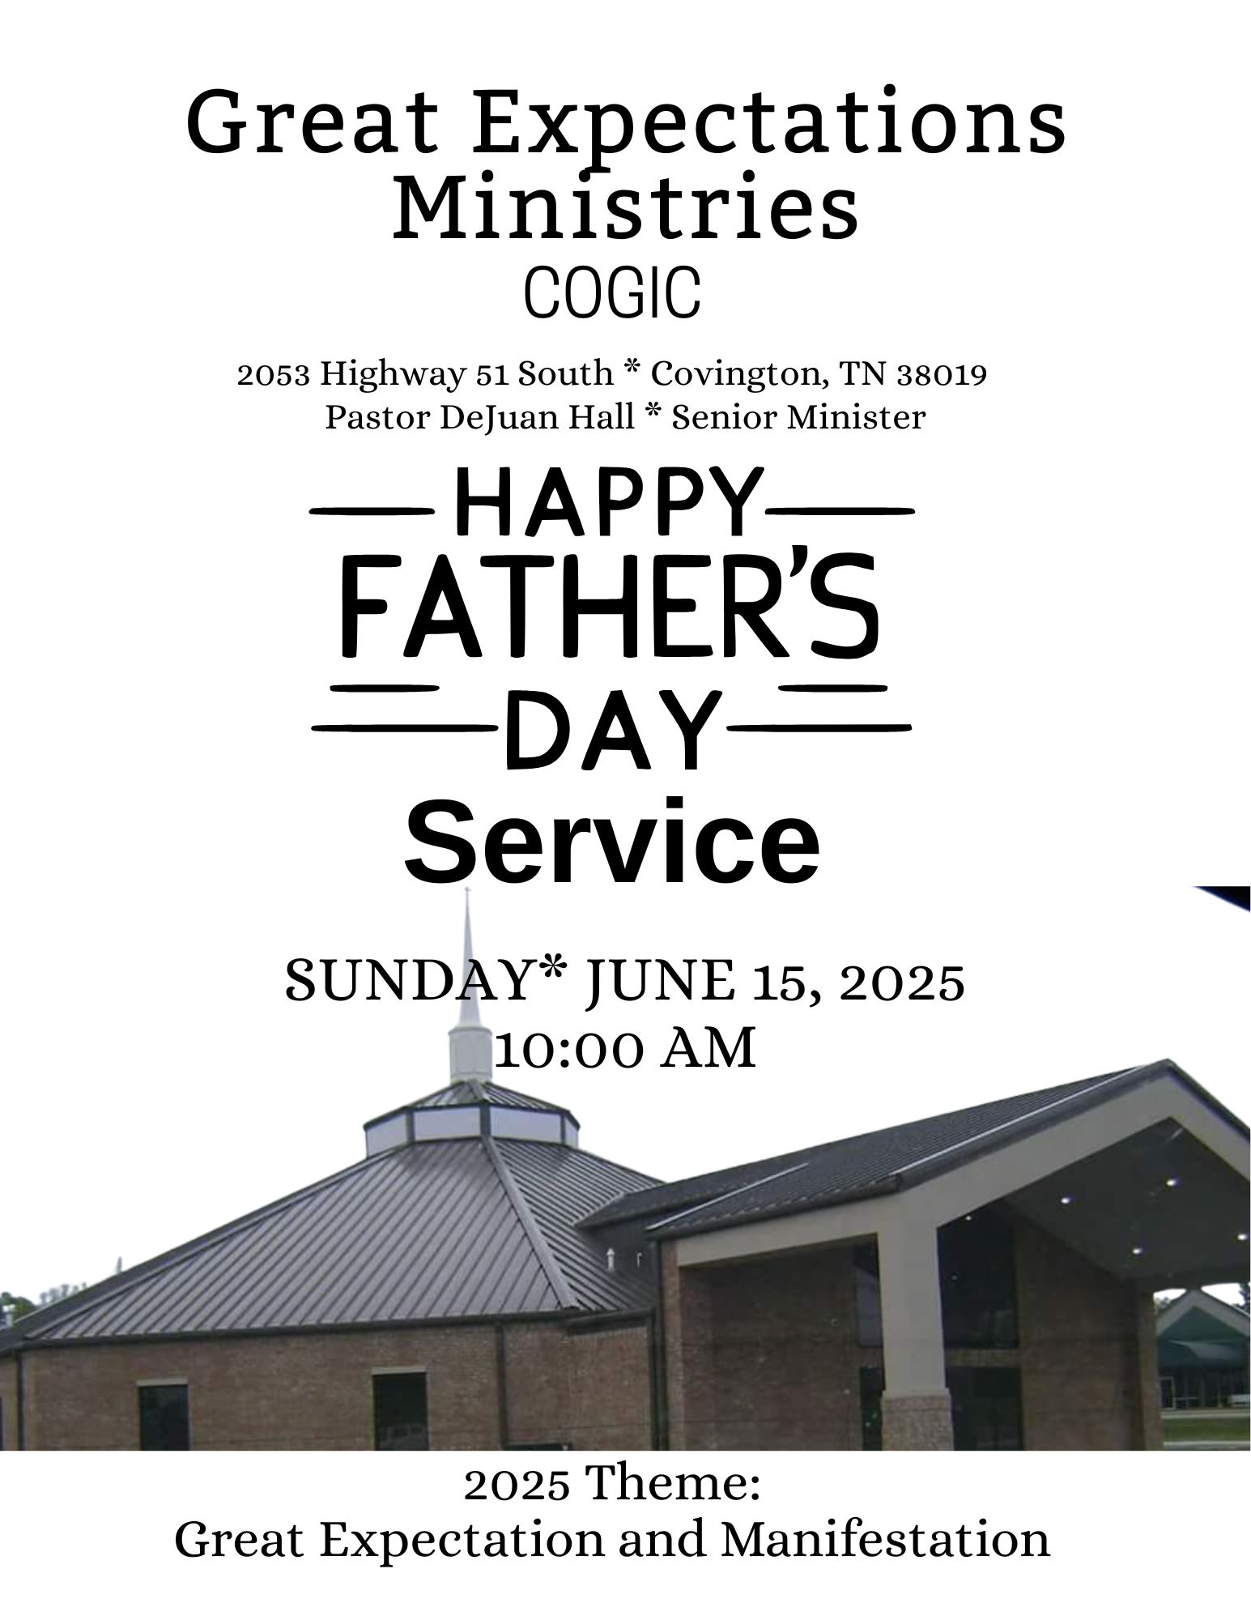
🎉 Welcome to Great Expectations Ministries COGIC! Father’s Day Service. We are so glad you joined us today as we honor and celebrate the strength, love, and leadership of fathers and father figures. On this special day, we give thanks to God for the men who reflect His heart, serve their families with grace, and lead with faith. Whether you're a father, grandfather, uncle, mentor, or spiritual father — today we celebrate you! May this service uplift your spirit and remind you of your God-given value and purpose.
💙 Happy Father’s Day! 🕊️ Let’s worship, celebrate, and grow in God’s Word together!
A SPECIAL DUAL CELEBRATION!

A great man of God is not known by fame, but by faith, service, and love. Pastor DeJuan Hall embodies all of these. We are truly blessed to have him leading our congregation. Thank you for your wisdom, encouragement, and love for God’s people, and being a light in our lives. Our celebration on July 13th, 10:00 am, will be two-fold. We will help Pastor DeJuan Hall celebrate his HALF-CENTURY birthday and a Good Shepherd service, in which we host every year just to say, “Thanks for your service”. We invite you to come, be a part of this two-fold event. We will continue this celebration with a fellowship luncheon which will be held in the Edward Lee Reed Fellowship Hall.



JUNE BIRTHDAYS
Minister DeRobert Adams 02
Deacon Robert Hall 07
Draden Burnett 11
Sister Darlene Catron 22

PRAYER LIST
Pastor DeJuan Hall & Family
Missionary Gwendolyn Hall
Sister Rosalind Doggett
Sis Yolanda Cunningham
Mrs. Angela Boddie- Alston
Pastor & Lady Charles Hayes
The Whitley Family

ANNIVERSARY
Bro & Sis Tom Burnett
June 24

SERVICE OPPORTUNITIES
Monday Noonday Prayer 12:00 pm
Tuesday Bible Study 7:00 pm
Sunday:
Morning Prayer 8:45am
Sunday School 9:00am *Worship Experience 10 am

The Worship Experience
*Please stand where denoted

*Call to Worship Deacon Stephen Hall
📖 Psalm 95:6–7 (NIV) Come, let us bow down in worship,
let us kneel before the Lord our Maker; for He is our God and we are the people of His pasture, the flock under His care.

*Prayer Deacon Robert Hall
Praise and Worship GEM Praise Team
Welcome and Observations Missionary Gwendolyn Hall
Offertory Scripture and Prayer Minister Douglas Young
📏 Offertory Scripture #3: Luke 6:38
"Give, and it will be given to you: a good measure—pressed down, shaken together, and running over—will be poured into your lap. For with the measure you use, it will be measured back to you."
Selection GEM Choir
The Message Pastor DeJuan Hall
The Call to Discipleship
Remarks and Benediction Pastor DeJuan Hall

