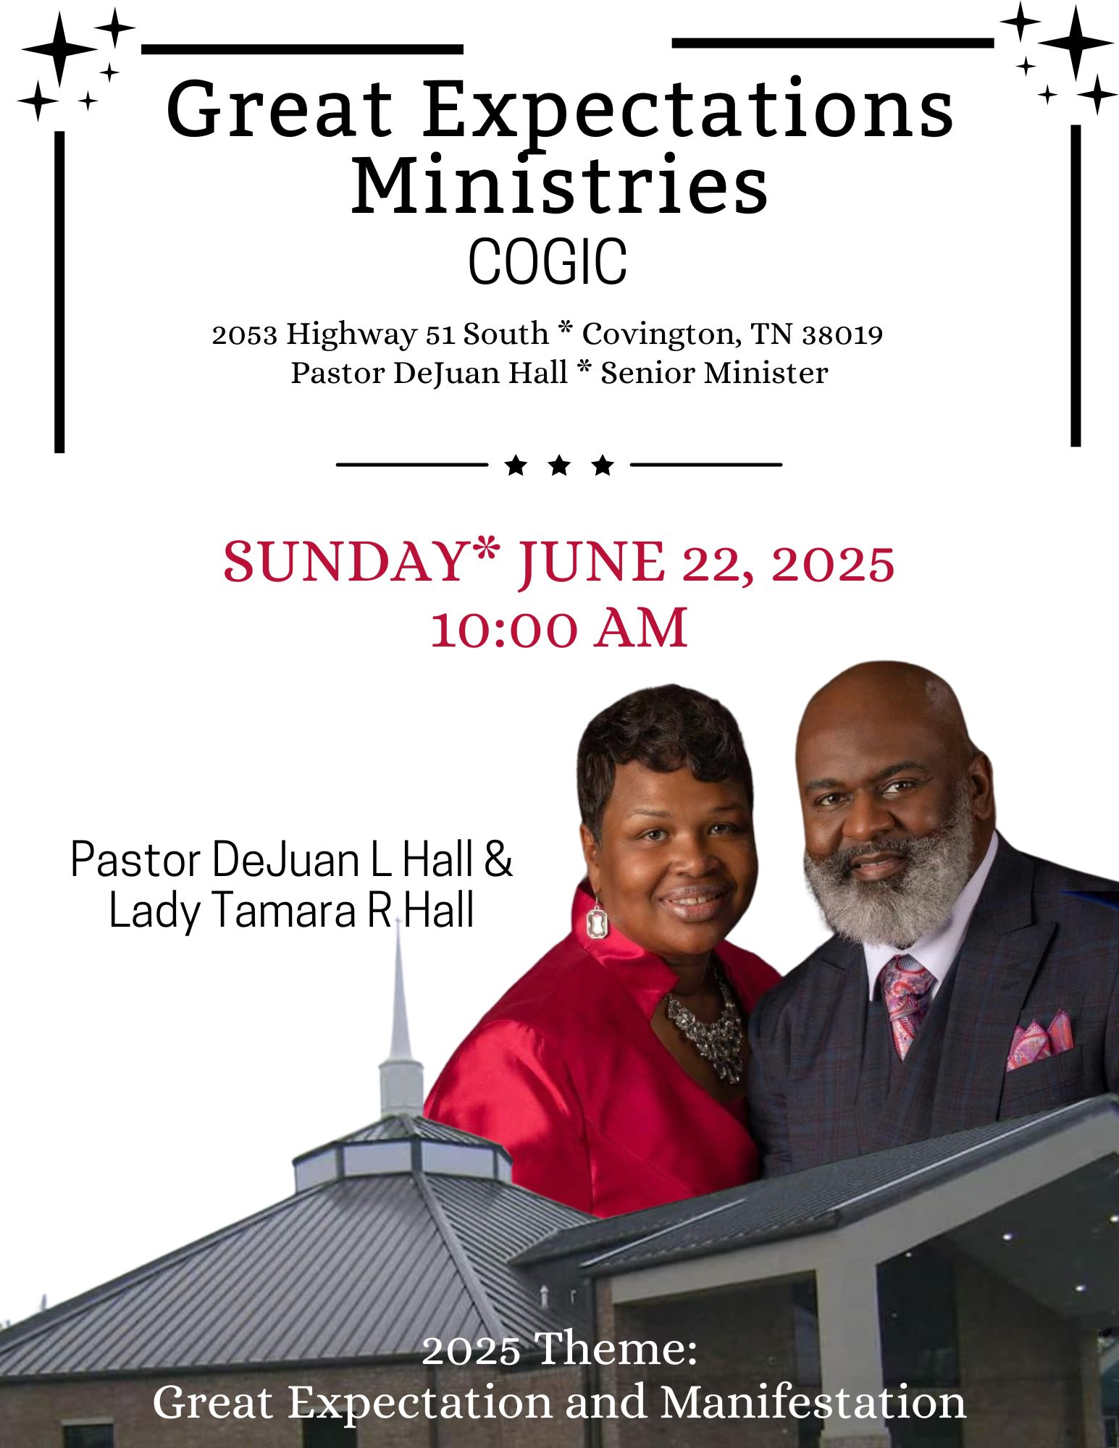
🎓 THE DEJUAN L. HALL EDUCATIONAL GRANT
of Great Expectations Ministries COGIC

In honor of academic achievement and Kingdom excellence, The DeJuan L. Hall Educational Grant is proud to recognize and bless a deserving student who has demonstrated outstanding performance in education, leadership, and character.

This deserving student will be chosen by the Grant and Scholarship Committee. Students interested, (going to 11th and 12th grades) you may complete an application (availability now) and return to Missionary Dorothy Hill-Davis by Sunday, June 22nd or e-mail to her at dorothy.aspire2mpower@gmail.com.

SCHOLARSHIP DONATION
The scholarship committee is requesting each member to donate $50 to the Scholarship Fund. Turn into the finance office, via your donation envelope, please. Thanks for your assistance.

VACATION BIBLE SCHOOL
THEME: RUN THE RACE (Hebrews 12:1-2)
June 24-26, 2025 * 6:00pm – 8:00pm
We hope you will join us for VBS 2025, sessions for children, teens, youth and adults. This is a great opportunity for you and your family to learn more about God in a friendly and exciting setting. We encourage you to take advantage of the available curricula offered below, and don’t forget to enjoy the refreshments available each night. Please make plans to attend Tuesday through Friday and invite your friends!

Please take advantage of pre-registrations by visiting the link provided here: https://greatexpectationsmincogic.com/vbs/
You will be able to download the curricula for VBS, as well. We will host the ACTIVITY night Friday, 6pm following VBS. All are invited!

🎉 Great Expectations Ministries COGIC Presents a Twofold Celebration!
Great Expectations Ministries COGIC joyfully invites you to a heartfelt celebration honoring our esteemed leader, Pastor DeJuan L. Hall, in a special twofold event:
🎉 50th Birthday Celebration
✝️ Good Shepherd Service
We are blessed to recognize both a milestone birthday and Pastor Hall’s faithful service as the shepherd to this ministry. Join us as we express our love, gratitude, and appreciation for the life and leadership of our pastor.
📅 Date: July 13, 2025
🕒 Time: 10:00 am
📍 Location: Great Expectations Ministries COGIC
Let us come together in unity to honor a man of vision, integrity, and Kingdom purpose.
"And I will give you pastors according to mine heart, which shall feed you with knowledge and understanding." – Jeremiah 3:15
*We will continue this celebration with a fellowship luncheon which will be held in the Edward Lee Reed Fellowship Hall.

SERVICE OPPORTUNITIES
Monday Noonday Prayer 12:00 pm
Tuesday Bible Study 7:00 pm
Sunday:
Morning Prayer 8:45am
Sunday School 9:00am *Worship Experience 10 am

Welcome to Great Expectations Ministries COGIC where Jesus Is Really Real and visitors are our honored guests!
💐We are delighted you are here today! May you experience the love of Christ, the power of His presence, and the joy of fellowship among believers. You are not just welcomed—you are wanted and celebrated!

PRAYER LIST
Pastor DeJuan Hall & Family
Missionary Gwendolyn Hall
Sister Rosalind Doggett
Sis Yolanda Cunningham
Mrs. Angela Boddie- Alston
Pastor & Lady Charles Hayes
The Whitley Family
Mrs. Shirlie Partee and family

ANNIVERSARY
Bro & Sis Tom Burnett
June 24

JUNE BIRTHDAYS
Minister DeRobert Adams 02
Deacon Robert Hall 07
Draden Burnett 11
Sister Darlene Catron 22



The Worship Experience
*Please stand where denoted

*Call to Worship Deacon Melvin Hicks
📖 Psalm 100:4–5 (ESV) Enter His gates with thanksgiving, and His courts with praise! Give thanks to Him; bless His name! For the Lord is good; His steadfast love endures forever, and His faithfulness to all generations.
*Prayer Deacon Jerry Hall
Praise and Worship GEM Praise Team
Welcome and Observations Missionary Gwendolyn Hall
*Offertory Scripture and Prayer Deacon Ronald Hall
🍇 Offertory Scripture: Proverbs 3:9-10
"Honor the Lord with your wealth and with the first fruits of all your increase; then your barns will be filled with plenty, and your vats will overflow with new wine."
Selection GEM Choir
The Message Pastor DeJuan Hall
The Call to Discipleship
Remarks and Benediction Pastor DeJuan Hall

