BIBLE STUDY
June 10th Min Douglas Young
17th Mother Eula Harris
24th Vacation Bible School

JUNE 2025 TEACHERS
SUNDAY SCHOOL
June 1 Eld. Richard Bateman
June 8 Deacon Ronald Hall
June 15 Missry Bobbie Topps
June 22 Minister Cletis Foster
June 29 Mother Eula Harris

VACATION BIBLE SCHOOL
THEME: RUN THE RACE (Hebrews 12:1-2)
June 24-26, 2025 * 6:00pm – 8:00pm
We hope you will join us for VBS 2025, sessions for children, teens, youth and adults. This is a great opportunity for you and your family to learn more about God in a friendly and exciting setting. We encourage you to take advantage of the available curricula offered below, and don’t forget to enjoy the refreshments available each night. Please make plans to attend Tuesday through Friday and invite your friends!

Please take advantage of pre-registrations by visiting the link provided here: https://greatexpectationsmincogic.com/vbs/
You will be able to download the curricula for VBS, as well. We will host the ACTIVITY night Friday, 6pm following VBS. All are invited!

🎉 VBS Participants Recognition 🎉
We are excited to announce that all student participants of Vacation Bible School 2025 will be recognized during our morning worship service on Sunday, June 29th! Let’s come together to celebrate their growth, learning, and enthusiasm as they ran the race of faith all week long. Families, friends, and the entire congregation are invited to join us in honoring our children for their dedication and participation.
Don’t miss this special celebration! 🏁✨

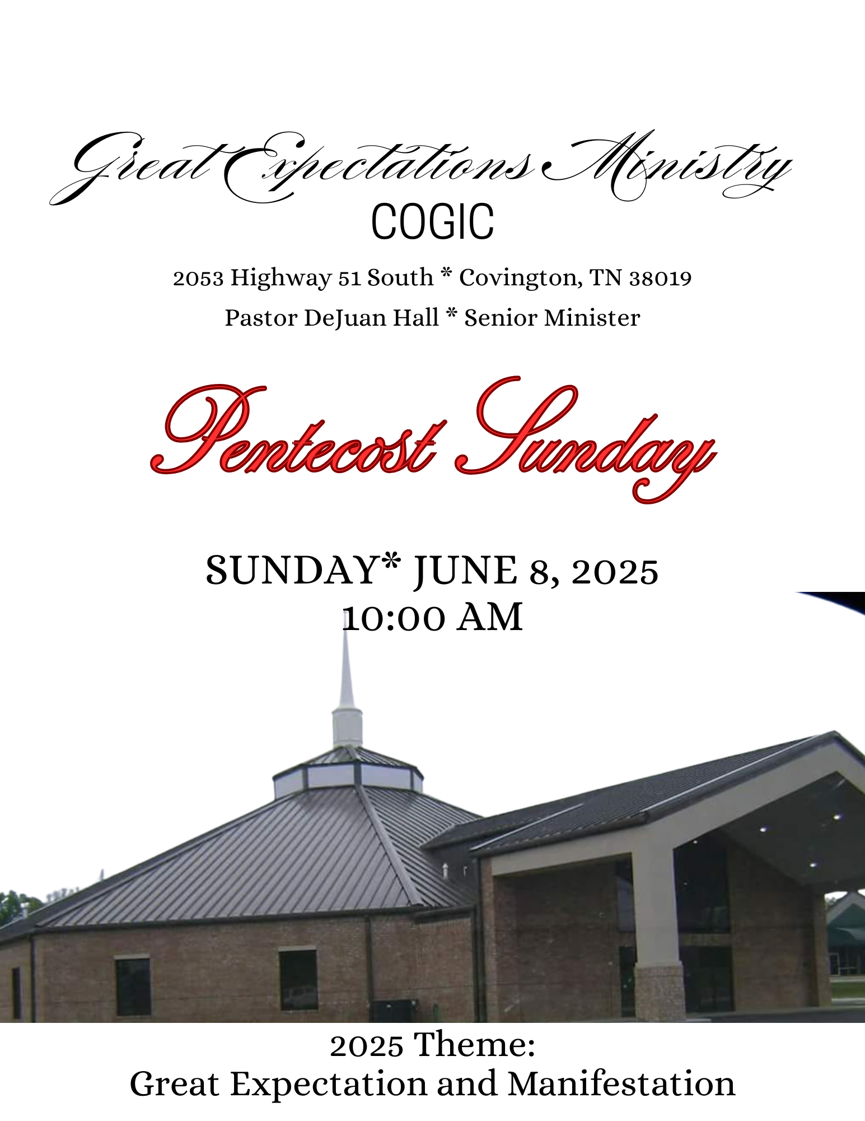

JUNE BIRTHDAYS
Minister DeRobert Adams 02
Deacon Robert Hall 07
Draden Burnett 11
Sister Darlene Catron 22

🌟 Welcome to Great Expectations Ministries COGIC 🌟
Pentecost Celebration Service

We are overjoyed that you’ve chosen to worship with us today as we celebrate the power and presence of the Holy Spirit on this blessed Pentecost Sunday! Today, we honor the outpouring of the Holy Spirit that birthed the church in power, unity, and boldness. Just as in the Upper Room, we come with great expectation—believing that God will move mightily in our midst.

Whether you are a long-time member or a first-time guest, we welcome you with open hearts and open arms. Let the fire of Pentecost ignite your spirit as we lift up the name of Jesus together! Get ready for a Spirit-filled experience of worship, Word, and wonder. This is your moment. This is your encounter. This is Pentecost!

SERVICE OPPORTUNITIES
Monday Noonday Prayer 12:00 pm
Tuesday Bible Study 7:00 pm
Sunday:
Morning Prayer 8:45am
Sunday School 9:00am *Worship Experience 10 am

The Worship Experience
*Please stand where denoted

*Call to Worship Deacon Melvin Hicks
"But you will receive power when the Holy Spirit comes on you; and you will be my witnesses in Jerusalem, and in all Judea and Samaria, and to the ends of the earth." Acts 1:8 (NIV)

*Prayer Deacon Jerry Hall
Praise and Worship GEM Praise Team
Welcome and Observations Sister LaToja Flowers

Offertory Scripture and Prayer Deacon Ronald Hall
📖 Proverbs 3:9–10 (KJV) "Honour the Lord with thy substance, and with the first fruits of all thine increase: So shall thy barns be filled with plenty, and thy presses shall burst out with new wine."
Selection GEM Choir
Presentation of Messenger Elder Richard Bateman
The Message Pastor DeJuan Hall
The Call to Discipleship
Remarks and Benediction Pastor DeJuan Hall


PRAYER LIST
Pastor DeJuan Hall & Family
Missionary Gwendolyn Hall
Sister Rosalind Doggett
Sis Yolanda Cunningham
Mrs. Angela Boddie- Alston
Pastor & Lady Charles Hayes

ANNIVERSARY
Bro & Sis Tom Burnett
June 24

