continued to serve under the leadership of the late Pastor Edward L Reed. Sister Fields is yet holding on as she continues her spiritual journey under the pastorale of Pastor DeJuan L Hall. Sister Fields has served our ministry in various capacities, including members of the usher board and hospitality committee. Sister Florence loves her family. She is the mother of one son and one daughter, and grandmother of three grandsons. We are pleased to have her as a member of our church family.

💌 Stay Connected
Website: [www.greatexpectationsmincogic.com ]
Email: [gministries2053@yahoo.com]
Facebook: https://www.facebook.com/groups/3085816058390275
Service Times: Sundays at 10 AM | Tuesdays at 7 PM

SISTER FLORENCE FIELDS a Tipton Countian acquired her formal education in the Tipton County School System. Sister Fields is a long-standing member of our ministry. She joined us the pastorate of the late Bishop Charles Rodgers and

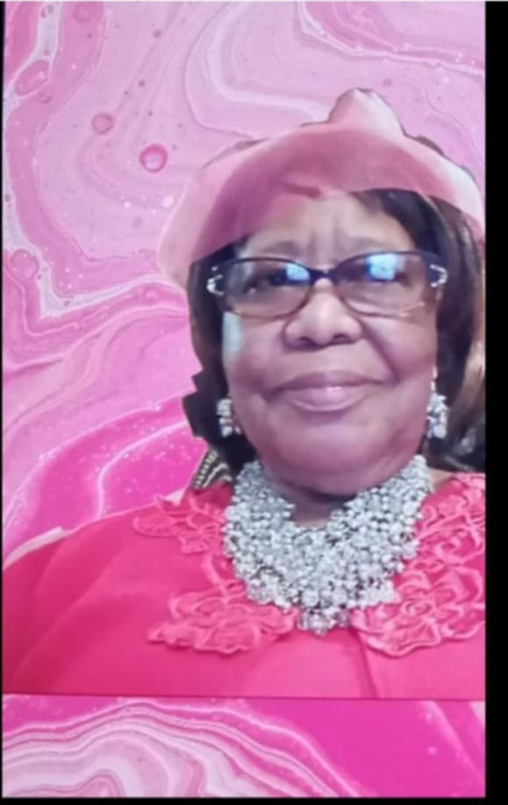
CHRISTIAN EDUCATION DEPARTMENT
ARISE
We encourage all children & preteens to join our classes at 9:00 am each Sunday. These are NOT your typical classes! Come, and See….

*****
REMEMBER! Tuesday, July 1st we will have our Special Men/Women Session taught by Pastor DeJuan Hall & Mother Eula Harris.



Noon Day Prayer (Mondays 12pm)
Bible Study (Tuesday 7:00 pm)
Sunday: 8:45 am Prayer
9:00 am Sunday School
10:00 am Worship Experience

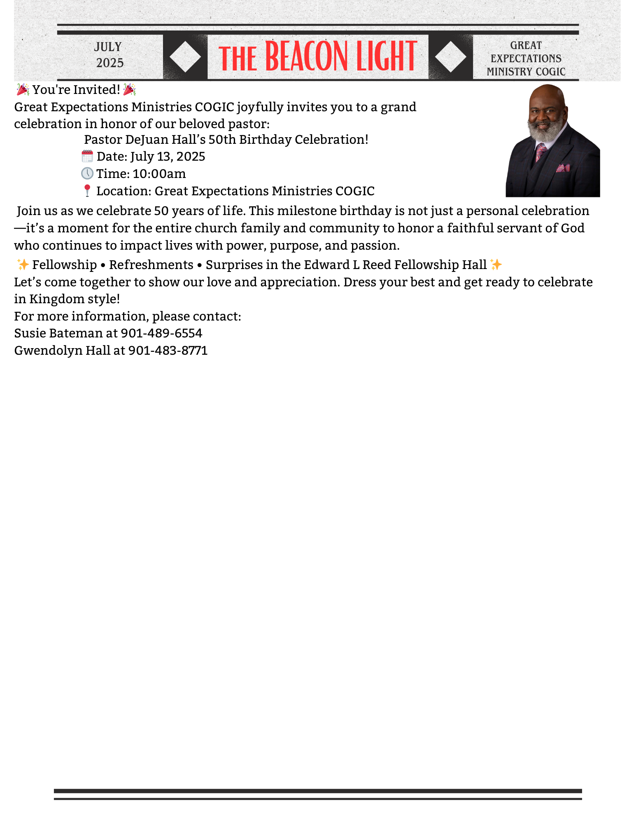
Sis Jacqueline Young 31st
***
Min & Sister
Doug Young 3rd

Dea & Sis
Ronald Hall 22nd

"Detach to Attach"
What can keep us from giving our all to God? Fear, anxiety, self-concern, preoccupation, and attachment to other things, just to name a few, can keep us from giving our all to God. Even spiritual things can get in the way of having God alone, as our treasure if we put them first. Detachment is a necessary step if we want to make the Lord our treasure and joy. It frees us to give ourselves without reserve to the Lord and to his service. There is nothing greater we can do with our lives than to place them
🎉 Member Milestones
Birthdays, Anniversaries
Sister Shalonda Craig 6th
Pastor DeJuan Hall 13th
Min Douglas Young 18th
Sister Sharon Blue 19th
Sis Rosalind Doggett 29th
Sister Cherlyn Seals 29th

📜 Mission Statement
“To win souls for Christ through the power of the Holy Spirit, empower believers to grow in faith, and equip them to live out their divine purpose with expectation and excellence.”
🗓 Upcoming Events
July 4th Independence Day
July 13th Pastor DeJuan Hall Birthday

them at the service of the Lord. We cannot outgive God in Generosity. Jesus promises that those who are willing to part with what is most dear to them for his sake we'll receive a hundred times as much and we're inherited eternal life (Matthews 19:29). So, the question is, is there anything holding you back from giving your all to the Lord? If so, DETACH yourself from it and ATTACH yourself to God. The bible says in Hebrews 12:1 "Let us lay aside every weight and the sin which doth so easily beset us and let us run with patience the race that is set before us." We Must DETACH TO ATTACH.
Pastor

THE PASTOR’S CORNER



